大事小事都好事 | 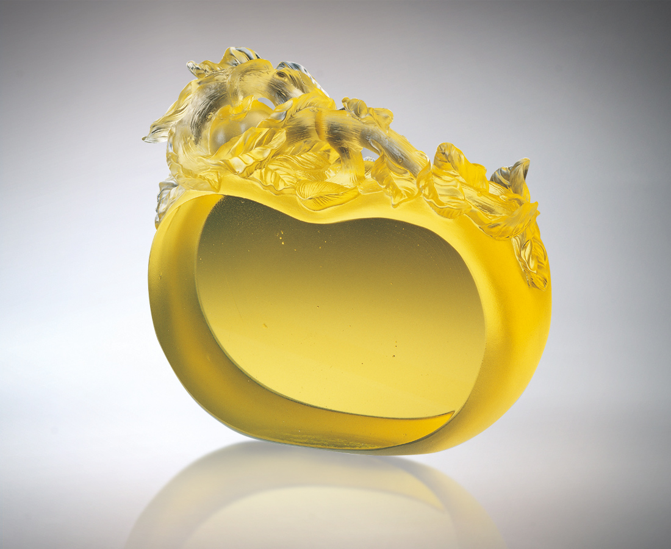
如意順遂的成長脈絡
是歲月是持續是胸襟
一點一滴的延綿因果
不是一步登天的奇蹟
不是偶然好運的成功
大事的雍容大度 是
小事細膩的堅持
信心 希望 努力
在剔透中欣欣向榮
一覽無遺
All Things Large or Small Are Good Things
Growth in line with one’s wishes The years, continuity, breadth of mind, is the drop by drop extension of cause and effect There is no miraculous leap to the heavens, occasional or fortuitous success The inclusiveness of large things is based on the insistence for detail in small things. Confidence, hope and industry Prosper in clarity For all to see

編號 | 1557066 | No | 1557066
名稱 | 大事小事都好事 | Name | All Things Large or Small Are Good Things
顏色 | 金 | Color
尺寸 | 6 * 16 * 12.7 | Size | 6 * 16 * 12.7
重量 | 1.8 | Weight | 1.8
限量 | O | Limited Edition | O
售價 | NT$ 15200 | Price | NT$ 15200
 | RMB$ 4188 |  | RMB$ 4188

