大福大壽大業 | 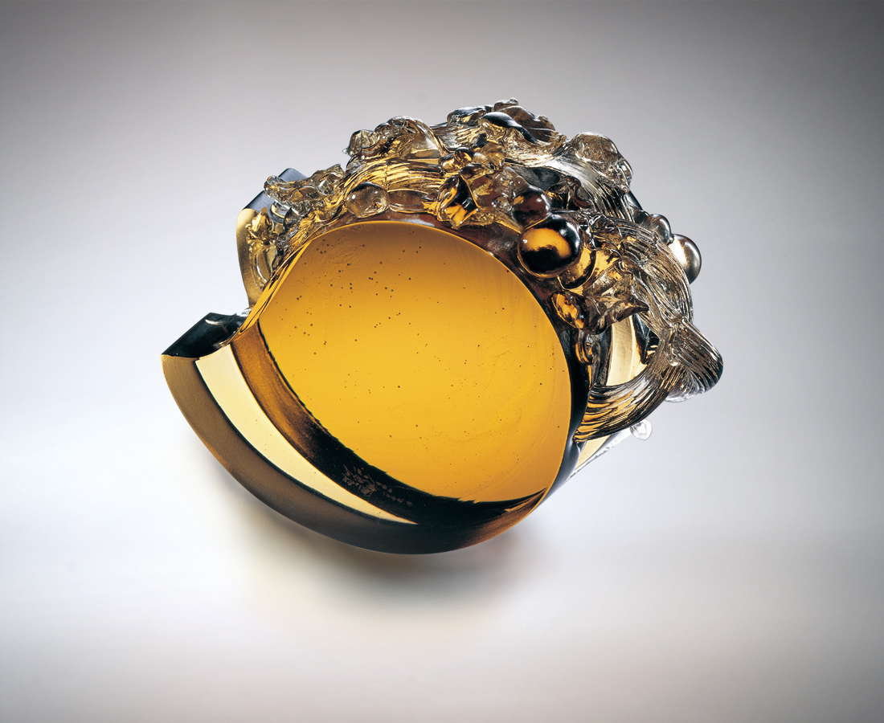
鐘鼎山林各創千秋
葫蘆以滋長蔓生
仔細敘述深植淵遠流長
福份的堅忍
壽桃以飽實碩果
透澈呈現一世審慎自省
慧命的圓融
在過程和成果交錯
共同完成大福大壽的
千秋大業
Great Blessings, Health and Achievements
Men of both high and low social status have their achievements passed on from one generation to the next The gourd grows spreading outwards Narrating in detail life’s depth of determination, good fortune steadfast and persevering The peach-shaped birthday cake is full of rich fruits Clearly showing the circumspect and introspective nature of the world, the mixture of wisdom and fate. At the intersection of process and results Jointly completing accomplishments that will be remembered

編號 | 1557065 | No | 1557065
名稱 | 大福大壽大業 | Name | Great Blessings, Health and Achievements
顏色 | 茶 | Color
尺寸 | 6.2 * 15.5 * 11.3 | Size | 6.2 * 15.5 * 11.3
重量 | 1.7 | Weight | 1.7
限量 | O | Limited Edition | O
售價 | NT$ 14200 | Price | NT$ 14200
 | RMB$ 3160 |  | RMB$ 3160

