萬丈光芒 | 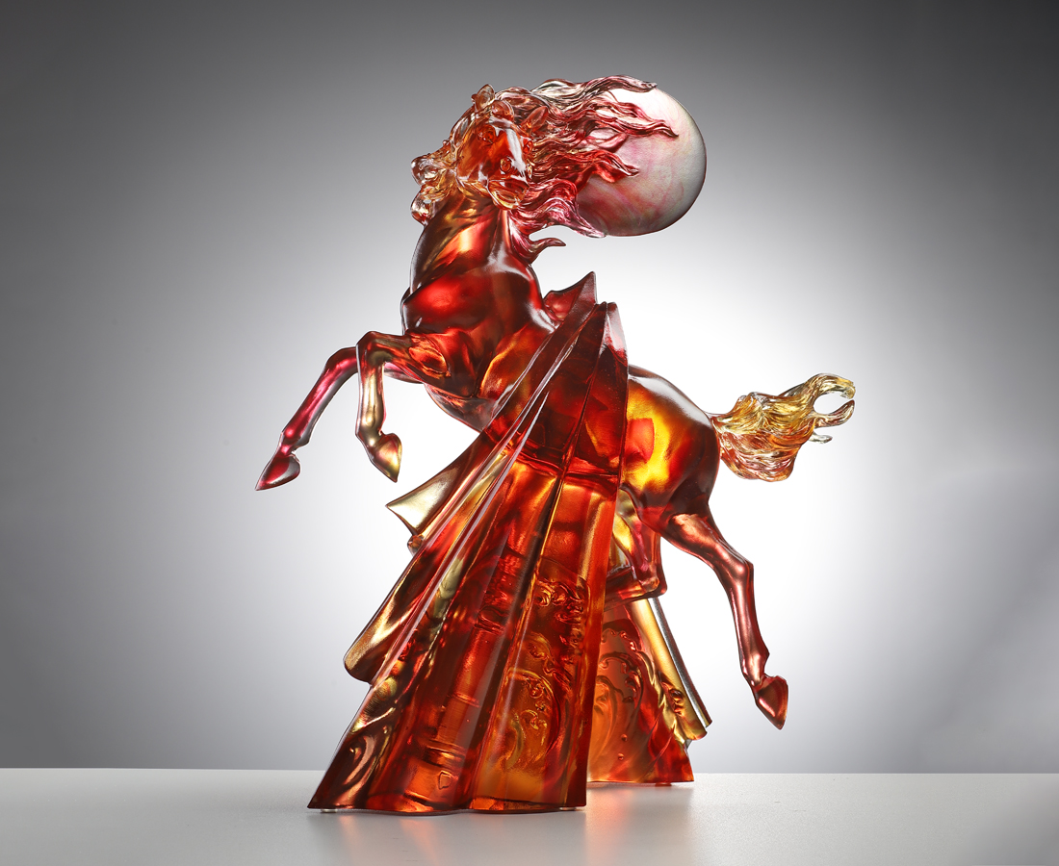
馬勢揚蹄 聲響踏千浪
朝曦東起 熠燿照四方
千錘極雄志 百鍊更剛烈
笑看來時斬棘路
日正當中 萬丈光芒
The Leaping Horse
In Chinese culture, the horse is the seventh animal of the zodiac and has long been cherished throughout history. Its traits, spirit, and posture carry many auspicious meanings. Among them, the image of a horse leaping into the air symbolizes courage, ambition, and the pursuit of dreams. In this design, sunlight is depicted as a flowing cape draped over the horse's back, symbolizing hope and the drive to pursue success.

編號 | 1554145 | No | 1554145
名稱 | 萬丈光芒 | Name | The Leaping Horse
顏色 | 琥紅透 | Color | red. amber, clear
尺寸 | 30.6 x 18.5 x 36.8 | Size | 30.6 x 18.5 x 36.8
重量 | 6.7 | Weight | 6.7
限量 | O | Limited Edition | O
售價 | NT$ 60800 | Price | NT$ 60800
 | RMB$ 13500 |  | RMB$ 13500

