八逸 | 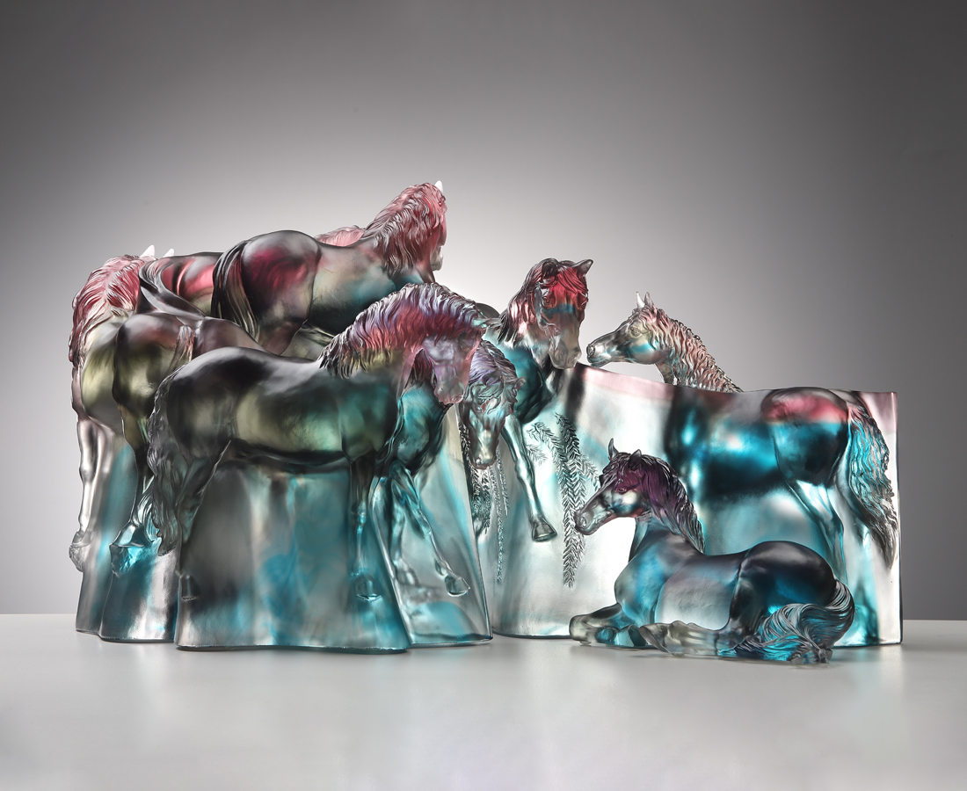
一逸琴中趣 韶音衍雅調
二逸棋中趣 縱橫顯英豪
三逸書中趣 執卷得精妙
四逸畫中趣 山水任逍遙
五逸詩中趣 遣興最風騷
六逸酒中趣 寬心品通宵
七逸花中趣 氛氳沐錦袍
八逸山中趣 鑾駕游古道
祥氣見徵 御極而逸
Leisure (Eight Horses)
The design of this item is inspired by the National Palace Museum’s collection, “Eight Horses”, by Lang Shining (Giuseppe Castiglione), Qing Dynasty. The painting scroll is reimagined as flowing lines of auspicious clouds and ruyi motifs, viewed from a bird’s-eye perspective. Through layered relief and three-dimensional sculpting techniques, the Eight Steeds appear to stride forth from the glazed scroll itself.

編號 | 1554144 | No | 1554144
名稱 | 八逸 | Name | Leisure (Eight Horses)
顏色 | 青灰紫透 | Color | cyan, gray, purple, clear
尺寸 | 64 x 39 x37 | Size | 64 x 39 x37
重量 | 51.0 | Weight | 51.0
限量 | O | Limited Edition | O
售價 | NT$ 288000 | Price | NT$ 288000
 | RMB$ 64000 |  | RMB$ 64000

