元首 | 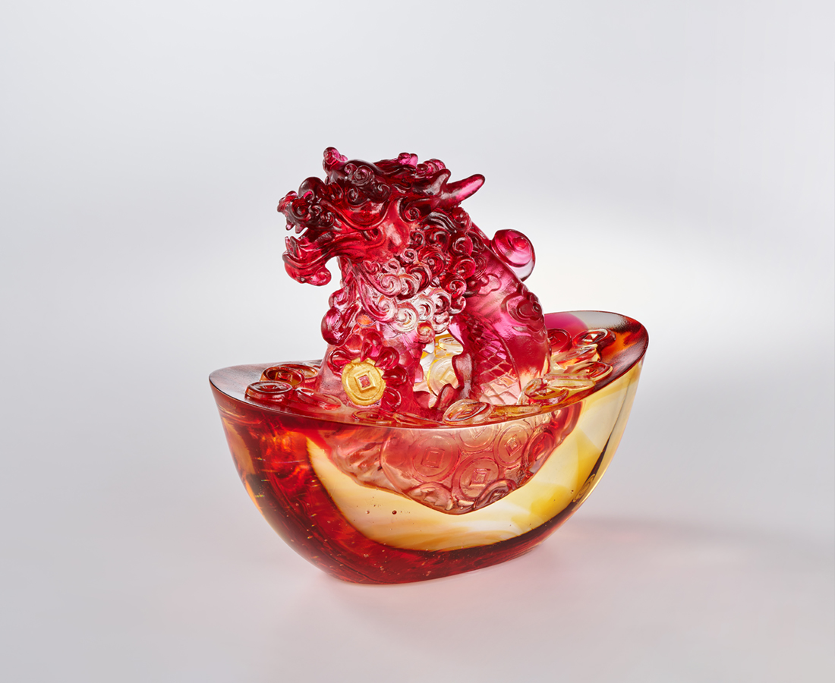
金玉耀目照光華
元氣氤氳滿人間
寶曆綿延貫古今
龍聲天語在心田
頭角崢嶸財源廣
吉兆並進蓬勃昌
祥物傳世 引領輝煌
The Chinese Dragon and the Yuan Bao
The Chinese dragon is the most representative animal in Chinese culture, symbolizing good fortune and power, as well as a sacred symbol of ancient imperial power. The work combines the Chinese dragon with the "Yuan Bao" (ancient Chinese currency), symbolizing leadership with the dragon's head, aspiring to guide the people in their quest for prosperity and wealth.

編號 | 1554104 | No | 1554104
名稱 | 元首 | Name | The Chinese Dragon and the Yuan Bao
顏色 | 金琥紅透+金箔 | Color | golden, amber, red, clear + gilding
尺寸 | 13.7 * 8.1 * 12.2 | Size | 13.7 * 8.1 * 12.2
重量 | 1.19 | Weight | 1.19
限量 | X | Limited Edition | X
售價 | NT$ 8800 | Price | NT$ 8800
 | RMB$ 1960 |  | RMB$ 1960

