扶搖 | 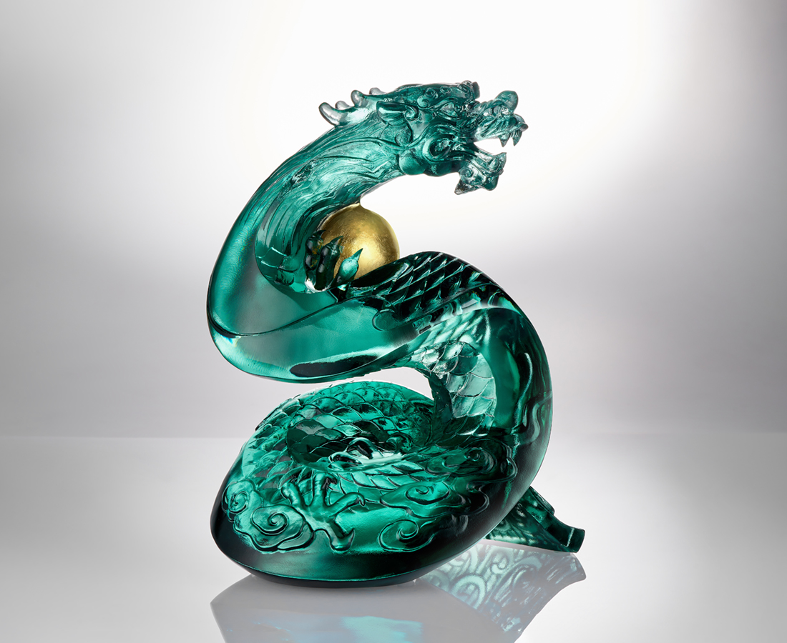
捲蒼穹青龍聚氣象
登凌雲驪珠映朝陽
乾坤變 萬化通
八方俊逸環頂峰
四海昇平貫長虹
The Chinese Dragon: Confidence in Stature
The Chinese dragon is the most representative animal in Chinese culture, symbolizing good fortune and power, as well as a sacred symbol of ancient imperial power. On the other hand, the "Dragon Pearl" is one of the most important images of the Chinese dragon, symbolizing the divine power that can bring rain to nourish all things and allow the dragon to transform freely. The work signifies how one's infinite talents enable one to manifest extraordinary charisma.

編號 | 1554103 | No | 1554103
名稱 | 扶搖 | Name | The Chinese Dragon: Confidence in Stature
顏色 | 海藍+金箔 | Color | marine Blue + gilding
尺寸 | 16.8 * 13 * 21.5 | Size | 16.8 * 13 * 21.5
重量 | 2.9 | Weight | 2.9
限量 | O | Limited Edition | O
售價 | NT$ 26800 | Price | NT$ 26800
 | RMB$ 5980 |  | RMB$ 5980

