月夕花朝 | 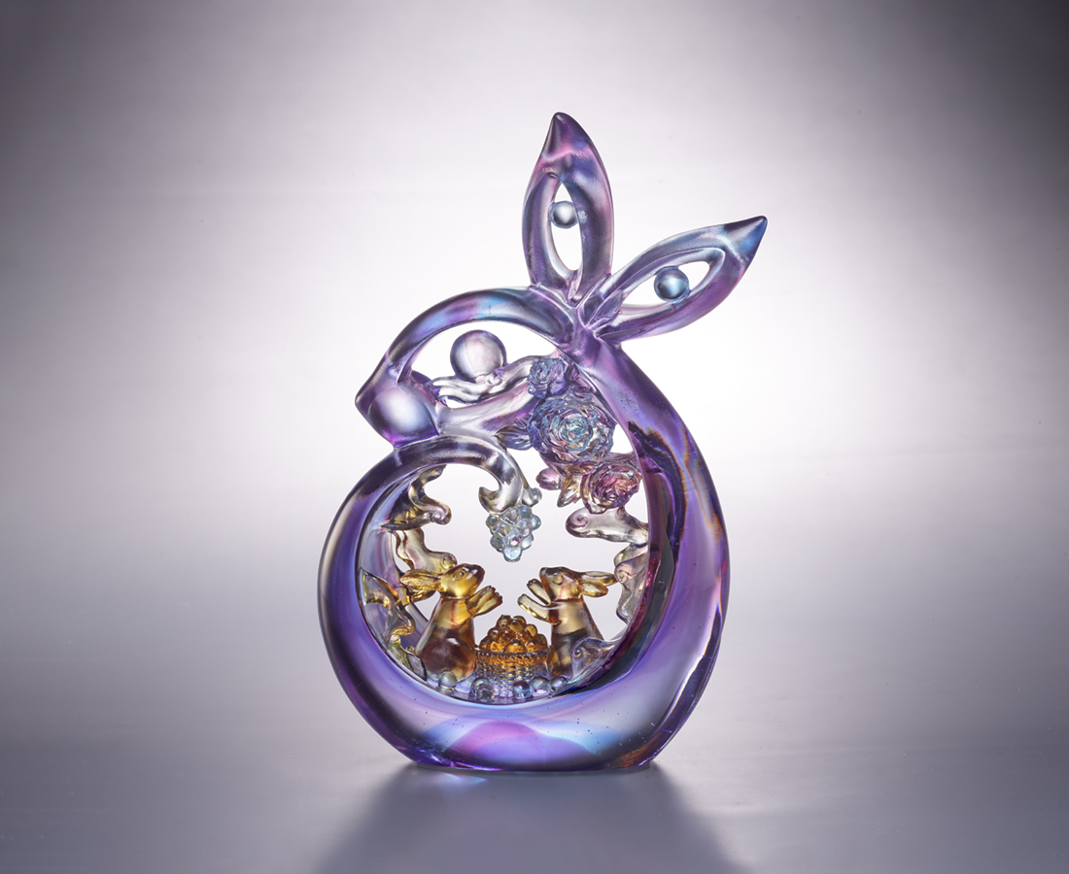
圓靈水鏡 列宿掩縟
羽裳玉杵詩酒仙
盛名遐邇唱千年
幽香裊裊 結果纍纍
月圓花好人長久
宵宴相伴白雲間
The Legend of the Rabbit on the Moon
In Chinese folklore, it is believed that the moon is inhabited by rabbits who make pills for immortality with a hammer. Gradually, rabbits are used to symbolize the moon in literary works. In this work, the eye of the rabbits is shaped into the full moon through the style of oriental paper-cutting art, while a pair of rabbits accompanying each other conveys the blessing of friendship and fullness.

編號 | 1554071 | No | 1554071
名稱 | 月夕花朝 | Name | The Legend of the Rabbit on the Moon
顏色 | 藍紫琥透 | Color | blue, purple, amber, clear
尺寸 | 14 * 6.4 * 22.5 | Size | 14 * 6.4 * 22.5
重量 | 1.37 | Weight | 1.37
限量 | X | Limited Edition | X
售價 | NT$ 15800 | Price | NT$ 15800
 | RMB$ 3780 |  | RMB$ 3780

