美夢圖 | 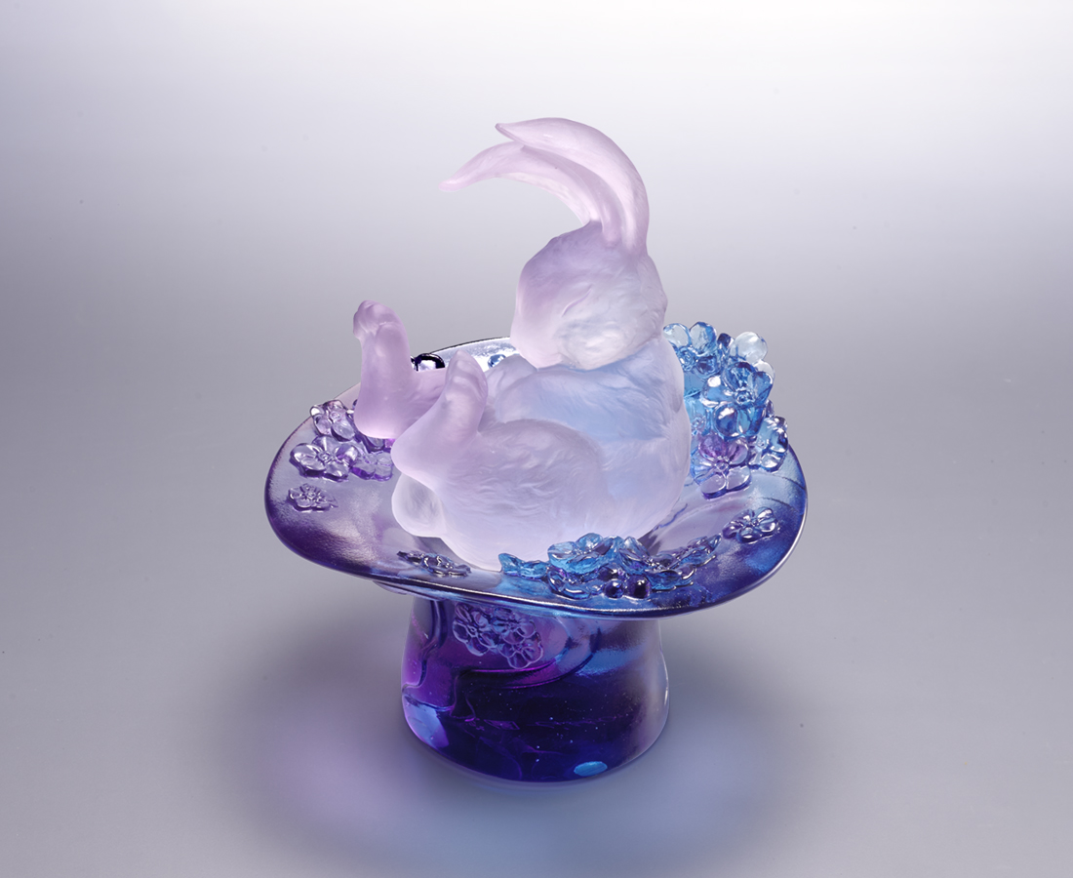
屏息張嘴
拔步 一手從容
企足翹首
拽起 一刻高潮
喜眉笑眼
見證 一生逸夢
Rabbit in a Hat
Inspired by magician's tricks, the work symbolizes the most beautiful things that people take care of through the sleeping rabbit. The purple forget-me-nots around the hat's brim speak of "eternal love".

編號 | 1554070 | No | 1554070
名稱 | 美夢圖 | Name | Rabbit in a Hat
顏色 | 粉紅透 + 藍紫透 | Color | pink, red, clear + blue, purple, clear
尺寸 | 12.9 * 11.7 * 14.7 | Size | 12.9 * 11.7 * 14.7
重量 | 1.1 | Weight | 1.1
限量 | X | Limited Edition | X
售價 | NT$ 8580 | Price | NT$ 8580
 | RMB$ 2050 |  | RMB$ 2050

