虎躍一方 | 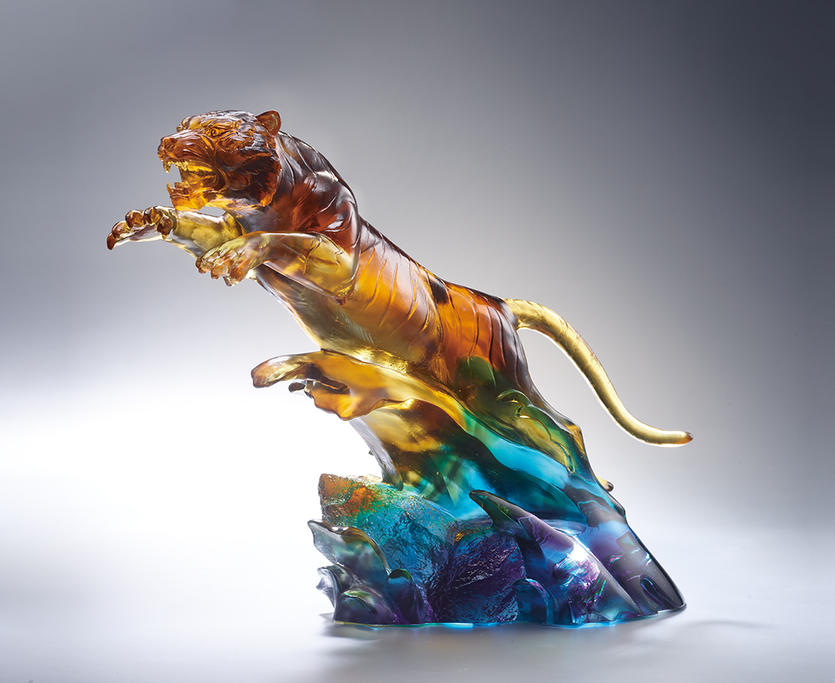
龍翻重淵千浪起
虎騰急濤百獸惶
心雄萬夫 四海相助
才謀遠圖 經緯壯志
天下近在眼前
Success Is at Head
The tiger is an auspiciously mythical beast and a valorous and powerful symbol. In the work, the tiger jumped up with the momentum of the waves, symbolizing that as long as there is determination, the whole environment will become a boost, and success will be at hand.

編號 | 1553981 | No | 1553981
名稱 | 虎躍一方 | Name | Success Is at Head
顏色 | 茶琥青灰透 | Color | brown, amber, cyan, gray, clear
尺寸 | 33 * 15 * 25.5 | Size | 33 * 15 * 25.5
重量 | 5.4 | Weight | 5.4
限量 | O | Limited Edition | O
售價 | NT$ 39800 | Price | NT$ 39800
 | RMB$ 8850 |  | RMB$ 8850

