圓抱福祿 | 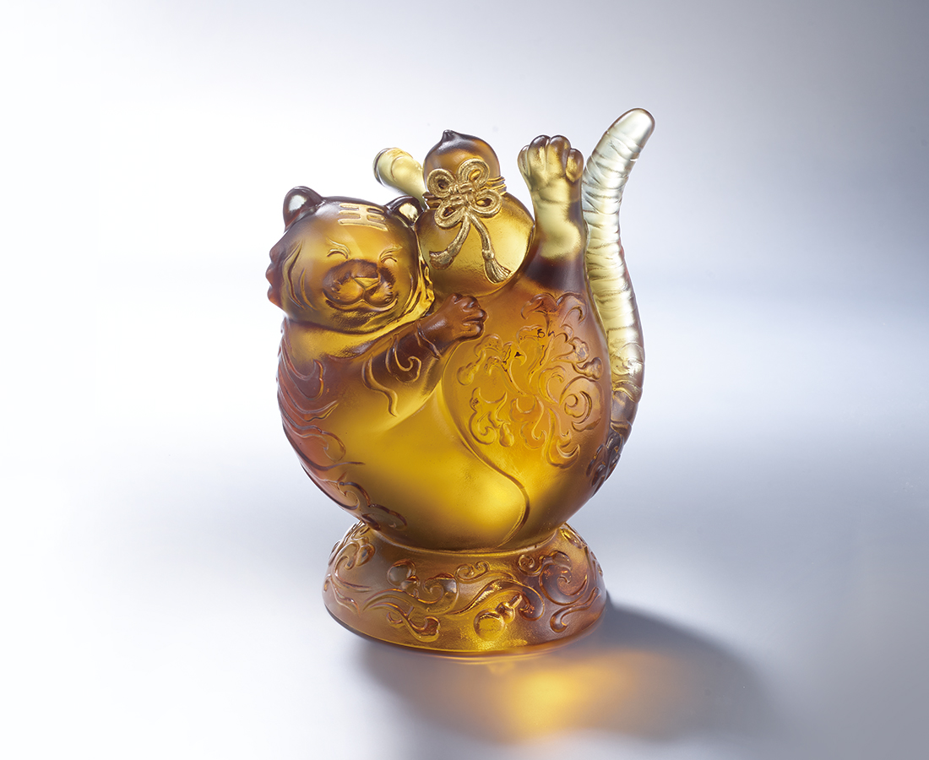
彈腰倚天地
圓身枕金波
畐蘆祭天 祈願
寸身言謝 感念
今日笑盈歡一回
明日抖擻向前程
區區丹抱 不負夙心
The Perfect and Satisfied Mind
The pronunciations of Chinese "tiger" and "fuqi" are similar. The gourd symbolizes the good fortune, so the tiger holding the gourd has the meaning of "good blessing". The tabby is presented with grass pattern of Tang style, adding oriental aesthetics to the work.

編號 | 1553979 | No | 1553979
名稱 | 圓抱福祿 | Name | The Perfect and Satisfied Mind
顏色 | 茶金+金箔 | Color | brown, golden + gilding
尺寸 | 12.5 * 10.5 * 18 | Size | 12.5 * 10.5 * 18
重量 | 2.7 | Weight | 2.7
限量 | O | Limited Edition | O
售價 | NT$ 12880 | Price | NT$ 12880
 | RMB$ 2880 |  | RMB$ 2880

