御天下 | 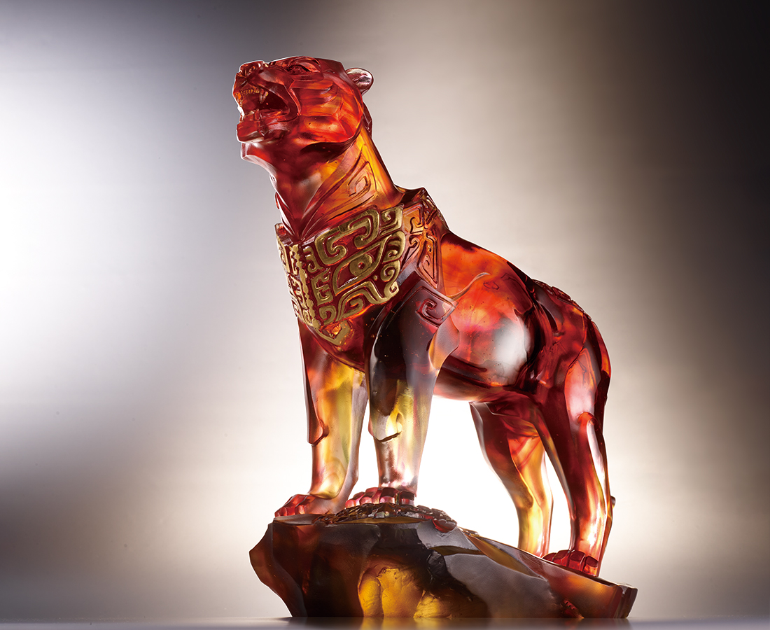
智者不惑 通曉磊落
仁者不憂 真誠確實
勇者不懼 養浩然之氣
唯知斯三者
修身治人御天下
Kingship
The tiger is an auspiciously mythical beast and a valorous and powerful symbol. In the work, the tiger that stands on the rock firmly looks forward, as if everything is under its feet. The armor that is the gluttonous pattern on the chest is a symbol of the ancient emperor.

編號 | 1553975 | No | 1553975
名稱 | 御天下 | Name | Kingship
顏色 | 琥紅茶灰透+金箔 | Color | amber, red, brown, gray, clear + gilding
尺寸 | 37.5 * 14 * 32 | Size | 37.5 * 14 * 32
重量 | 10.8 | Weight | 10.8
限量 | O | Limited Edition | O
售價 | NT$ 118000 | Price | NT$ 118000
 | RMB$ 26220 |  | RMB$ 26220

