耄耋悠然 | 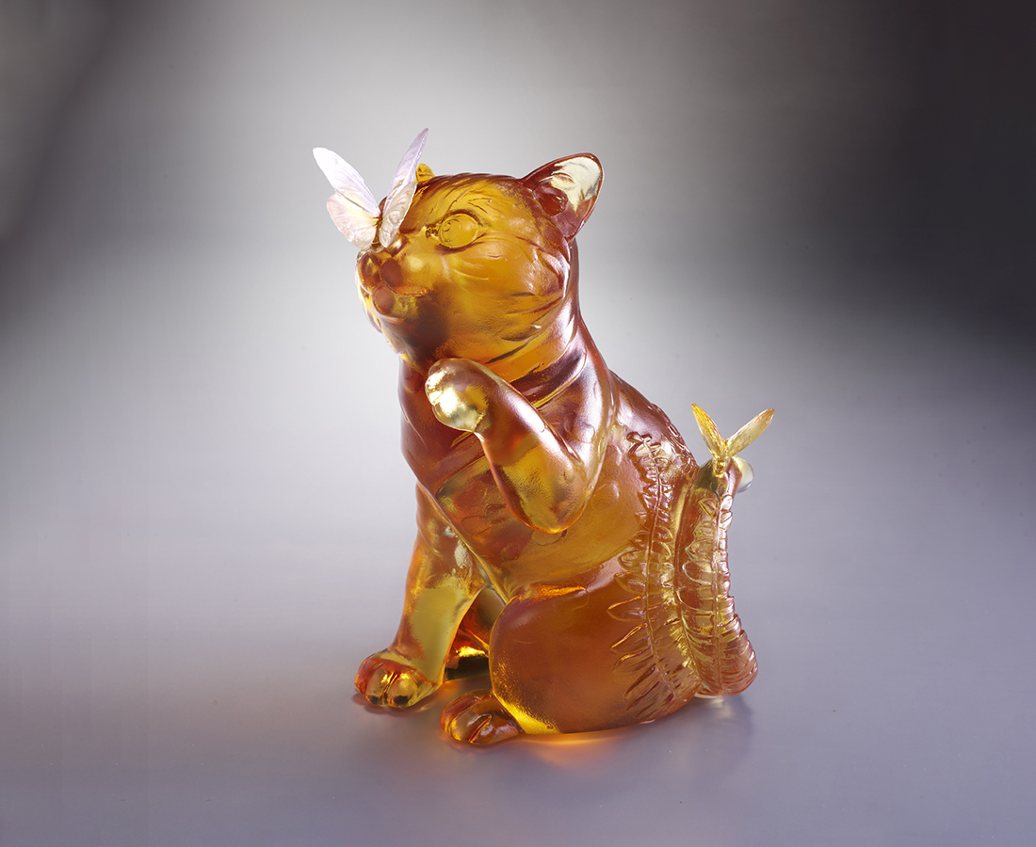
泠水煎茶 醉淡泊
滿袖春秋 自開懷
如飲醇醪 大智天和
The Capture of Fortune
Tiger, one of the Chinese mythical beasts, symbolizes auspiciousness. The butterfly, on the other hand, is homophone of “incessant fortune” in Chinese. Combining the two creatures into one scenery, the work embodies blessings of auspiciousness and fortune.

編號 | 1553964 | No | 1553964
名稱 | 耄耋悠然 | Name | The Capture of Fortune
顏色 | 琥透 | Color | amber, clear
尺寸 | 10.5 * 7.5 * 14 | Size | 10.5 * 7.5 * 14
重量 | 0.88 | Weight | 0.88
限量 | X | Limited Edition | X
售價 | NT$ 7680 | Price | NT$ 7680
 | RMB$ 1710 |  | RMB$ 1710

