福運滾滾 | 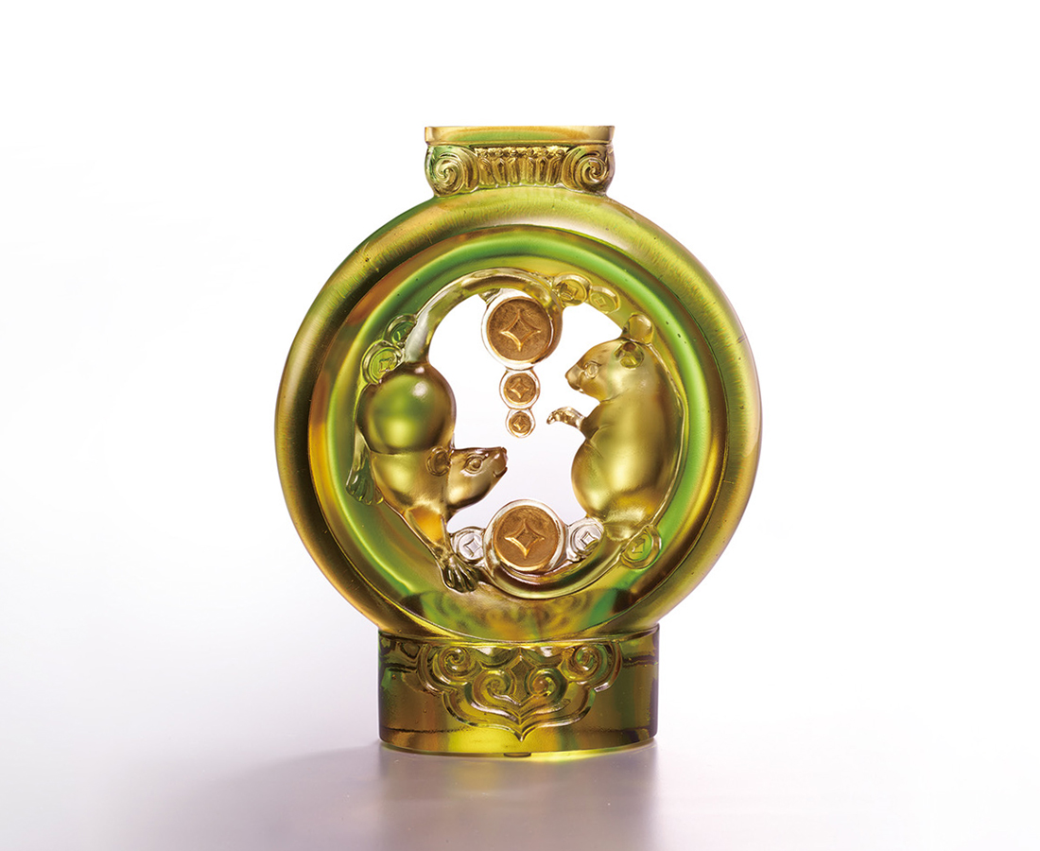
繞個圈 左右逢源
既和氣 又報喜
財運滾滾來
探個頭 福祿滿懷
你升官 又添丁
如意天天在
Fortune Rolling In
The mouse, as the head of Chinese animal sign, symbolizes fortune and prosperity in the traditional culture. The artwork, with the appearance of a Chinese lantern, is brimming with happiness and joy brought by Chinese New Year. The two mice running around decorated by a gourd and a gold coin merge to express the blessings of fortune rolling in.

編號 | 1553900 | No | 1553900
名稱 | 福運滾滾 | Name | Fortune Rolling In
顏色 | 金綠透 + 金箔 | Color | golden, green, clear + gilding
尺寸 | 13.8 * 5.3 * 17.3 | Size | 13.8 * 5.3 * 17.3
重量 | 1.3 | Weight | 1.3
限量 | X | Limited Edition | X
售價 | NT$ 13680 | Price | NT$ 13680
 | RMB$ 3050 |  | RMB$ 3050

