豐收滿盈 | 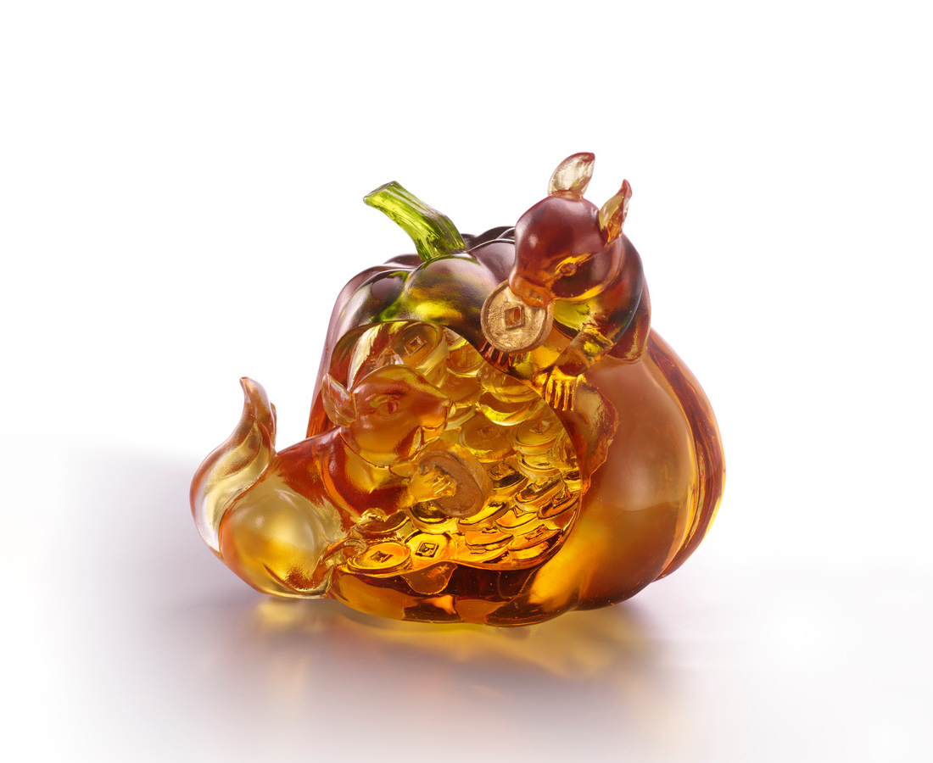
崇山基於細石
涓滴也能成河
牢記初心 不忘來路
齊心協力 互助合作
一步步 一階階 終能
喜慶豐收樂滿盈
Squirrel and Pumpkin
The mouse, as the head of Chinese animal sign, symbolizes fortune and prosperity in the traditional culture. Pumpkin, on the other hand, indicates wealth. The artwork, with two squirrels having pumpkin as their home, working side by side for a house of coinage, conveys the value of teamwork and diligence.

編號 | 1553899 | No | 1553899
名稱 | 豐收滿盈 | Name | Squirrel and Pumpkin
顏色 | 琥綠透 + 金箔 | Color | amber, green, clear + gilding
尺寸 | 13.2 * 9.1 * 12.3 | Size | 13.2 * 9.1 * 12.3
重量 | 1.5 | Weight | 1.5
限量 | X | Limited Edition | X
售價 | NT$ 11800 | Price | NT$ 11800
 | RMB$ 2650 |  | RMB$ 2650

