富貴開門 | 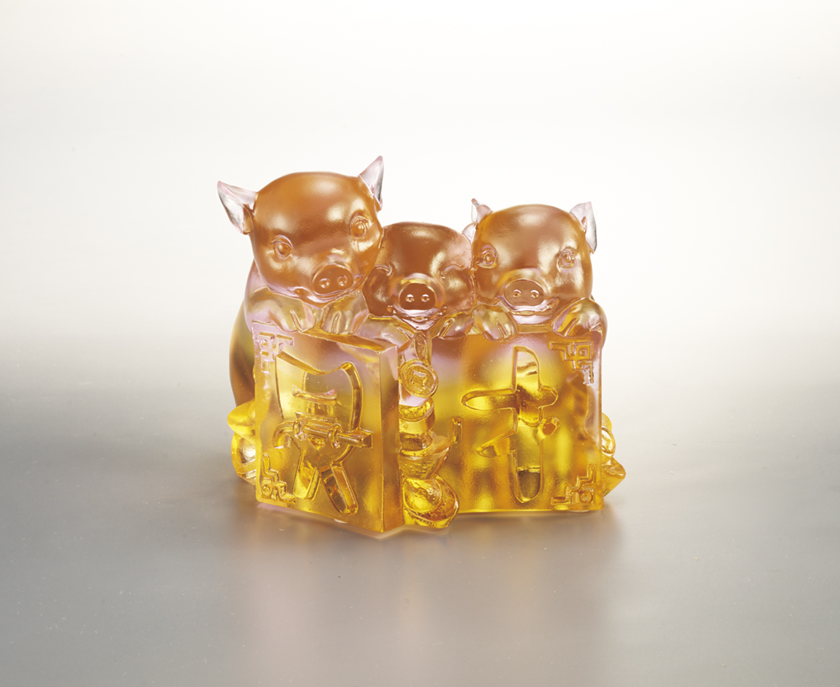
立定每一個根基
深耕每一次機會
珍惜每一份好緣
人生運勢從此坦順
家肥屋潤 富貴開門
Pig of Treasury
Pig, by its cute and honest appearance, symbolizes affluence and optimism in Chinese Culture. Tittot combines its smiley face with Chinese Gold Ingot, conveying as long as people can be kind to one another, all can enjoy a merry life.

編號 | 1553859 | No | 1553859
名稱 | 富貴開門 | Name | Pig of Treasury
顏色 | 粉紅琥 | Color | pink, amber
尺寸 | 9 * 10 * 9 | Size | 9 * 10 * 9
重量 | 1.15 | Weight | 1.15
限量 | O | Limited Edition | O
售價 | NT$ 5880 | Price | NT$ 5880
 | RMB$ 1310 |  | RMB$ 1310

