自信 | 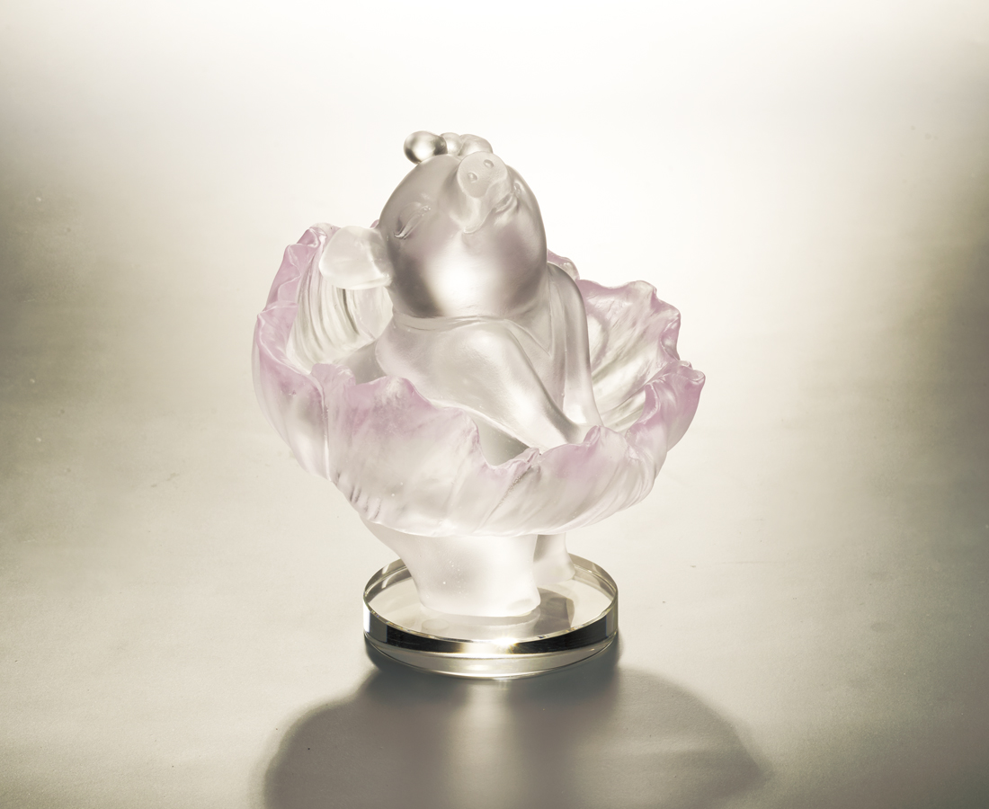
風格 應該被欣賞
有愛 就應該勇敢
誠實的愛自己
自信的愛自己
我的風格就是我自己
The Dancing Skirt
Tittot uses the signature pose of famous pop star Marilyn Monroe as topic, while design by adding in Chinese elements. The pulled-up skirt is like bloomed peony, emphasizing female do not need to mind other’s opinion, instead should create her own style by her confidence.

編號 | 1553858 | No | 1553858
名稱 | 自信 | Name | The Dancing Skirt
顏色 | 粉紅透 + K9底座 | Color | pink, clear + k9
尺寸 | 11 * 10.5 * 12 | Size | 11 * 10.5 * 12
重量 | 0.82 | Weight | 0.82
限量 | O | Limited Edition | O
售價 | NT$ 6880 | Price | NT$ 6880
 | RMB$ 1530 |  | RMB$ 1530

