發哥 | 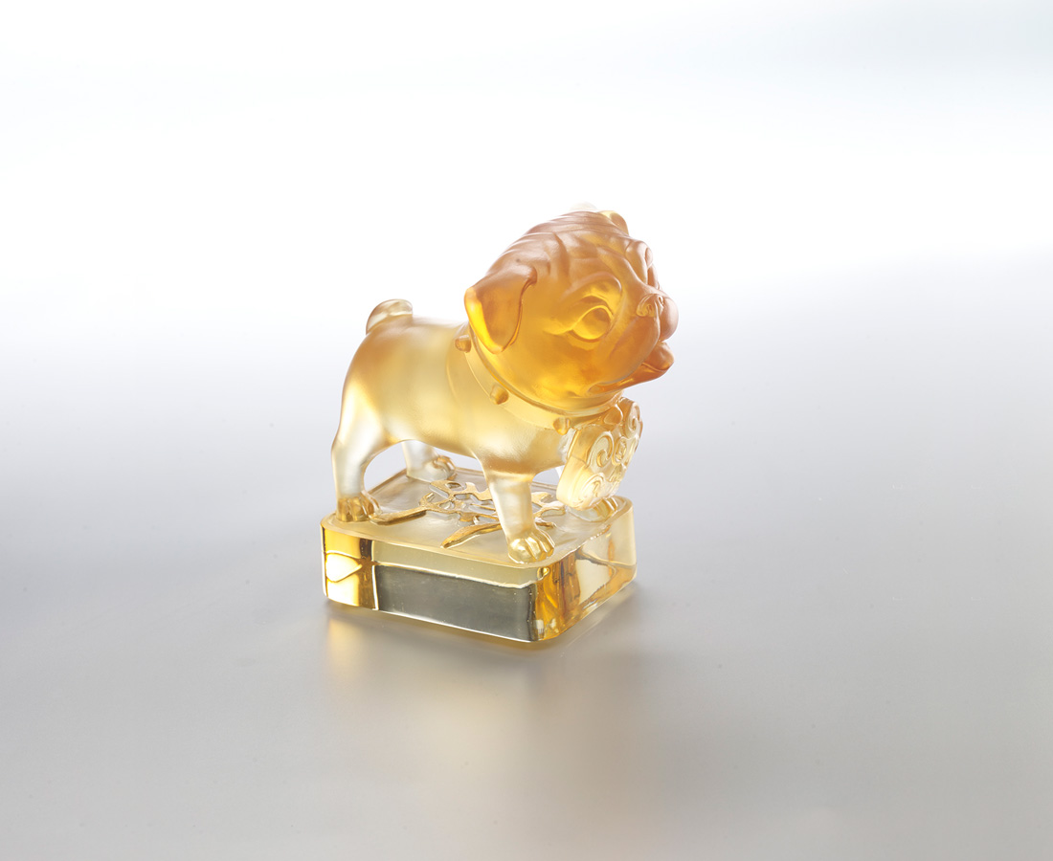
緩有緩的可愛
拙有拙的趣味
樂天知命 從容隨緣
你拉著我 我推著你
一起往上走吧
隨時都是新出發
Pug
“Fa” in Chinese sounds similar to “pug” and “Fa” means smooth development as well. The gorgeous pug on the base with “Fa” wishes everyone well on life and work.

編號 | 1553811 | No | 1553811
名稱 | 發哥 | Name | Pug
顏色 | 琥透＋金箔 | Color | amber, clean + gilding
尺寸 | 10.4 * 6.9 * 11 | Size | 10.4 * 6.9 * 11
重量 | 0.75 | Weight | 0.75
限量 | X | Limited Edition | X
售價 | NT$ 5380 | Price | NT$ 5380
 | RMB$ 1200 |  | RMB$ 1200

