好機會 | 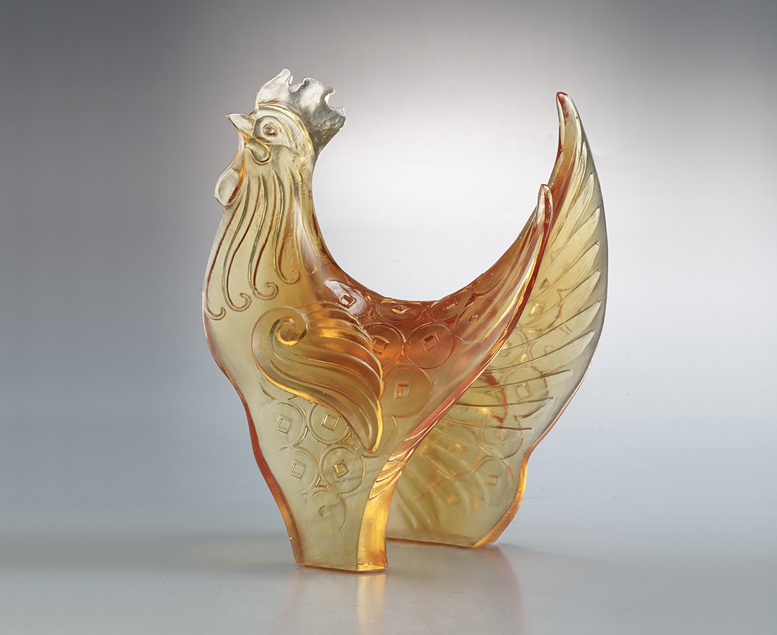
不拘泥 不眷戀
掌握每一個轉折的機會
事事大吉 吉慶得利
Opportunities
The design with pieces of glass makes this art piece suitable to be viewed from different angles. Turning will see a new opportunity.

編號 | 1553722 | No | 1553722
名稱 | 好機會 | Name | Opportunities
顏色 | 金琥 | Color | golden, amber
尺寸 | 12.4 * 8.7 * 16.5 | Size | 12.4 * 8.7 * 16.5
重量 | 0.66 | Weight | 0.66
限量 | X | Limited Edition | X
售價 | NT$ 6680 | Price | NT$ 6680
 | RMB$ 1480 |  | RMB$ 1480

