燦爛風華 | 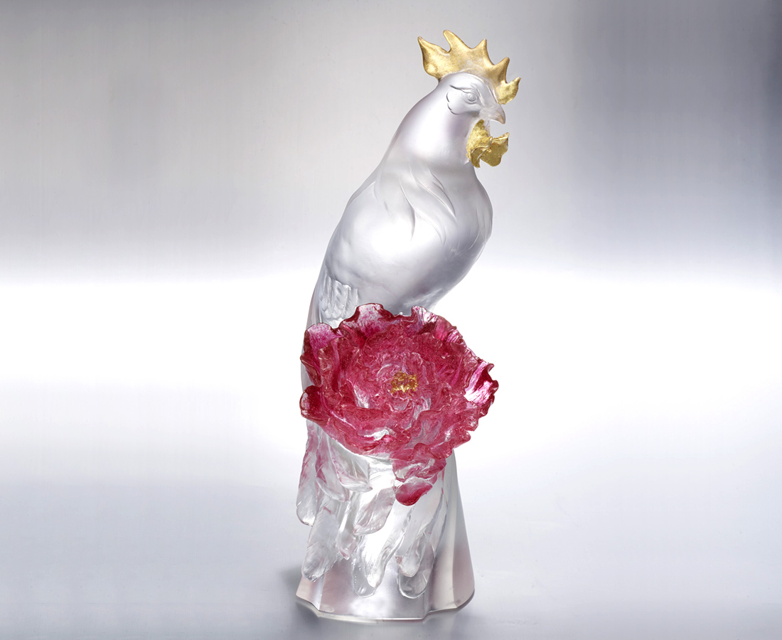
享受每天的驚喜
每一鳴都富貴驚人
喚醒燦爛風華之境
Peony Flower and Long-tailed Rooster
Tittot uses flowing lines to shape the rooster’s colorful long tail, decorated with the Peony Flower to generate a gorgeous image, fully presenting the delicacy of handicraft art.

編號 | 1553719 | No | 1553719
名稱 | 燦爛風華 | Name | Peony Flower and Long-tailed Rooster
顏色 | 紅透＋金箔 | Color | red, clear + gilding
尺寸 | 19.9 * 13.9 * 39.3 | Size | 19.9 * 13.9 * 39.3
重量 | 7.48 | Weight | 7.48
限量 | O | Limited Edition | O
售價 | NT$ 46800 | Price | NT$ 46800
 | RMB$ 10400 |  | RMB$ 10400

