王者之風 | 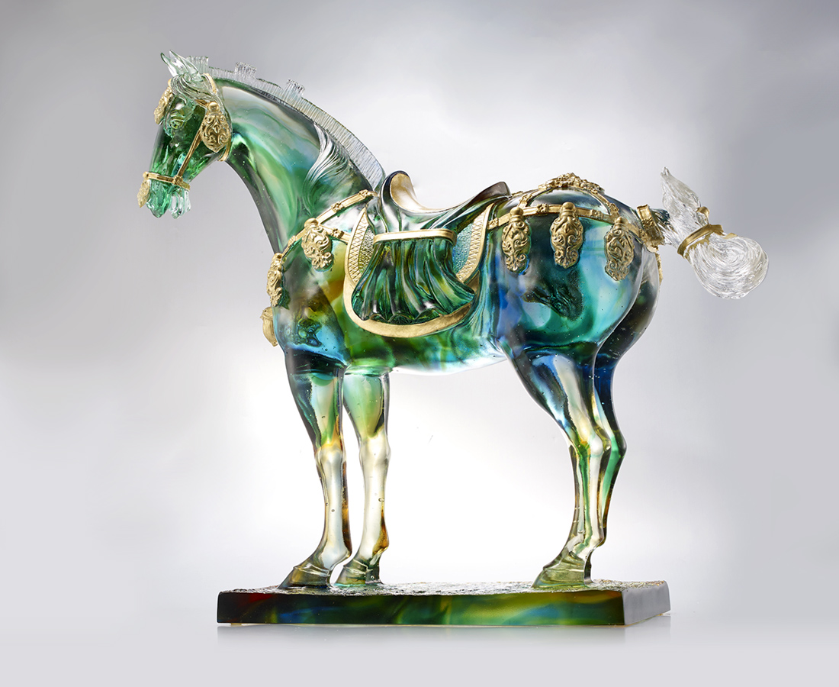
適時而起
不疾不徐
每一步 恰到好處
每一著 王者之風
Tricolor Horse of Tang Dynasty
Tittot takes the concept of the Tricolor Horse of the Tang Dynasty, using smooth colors to give perfect interpretation of the gorgeous Tricolor Horse, with delicate carving of the muscular body to present the exuberant vitality of the Tang Dynasty.

編號 | 1553671 | No | 1553671
名稱 | 王者之風 | Name | Tricolor Horse of Tang Dynasty
顏色 | 藍青綠琥透＋金箔 | Color | blue ,cyan ,green ,amber ,clear＋gilding
尺寸 | 55 * 19.8 * 51.6 | Size | 55 * 19.8 * 51.6
重量 | 31.5 | Weight | 31.5
限量 | O | Limited Edition | O
售價 | NT$ 396000 | Price | NT$ 396000
 | RMB$ 81800 |  | RMB$ 81800

