榮耀登臨 | 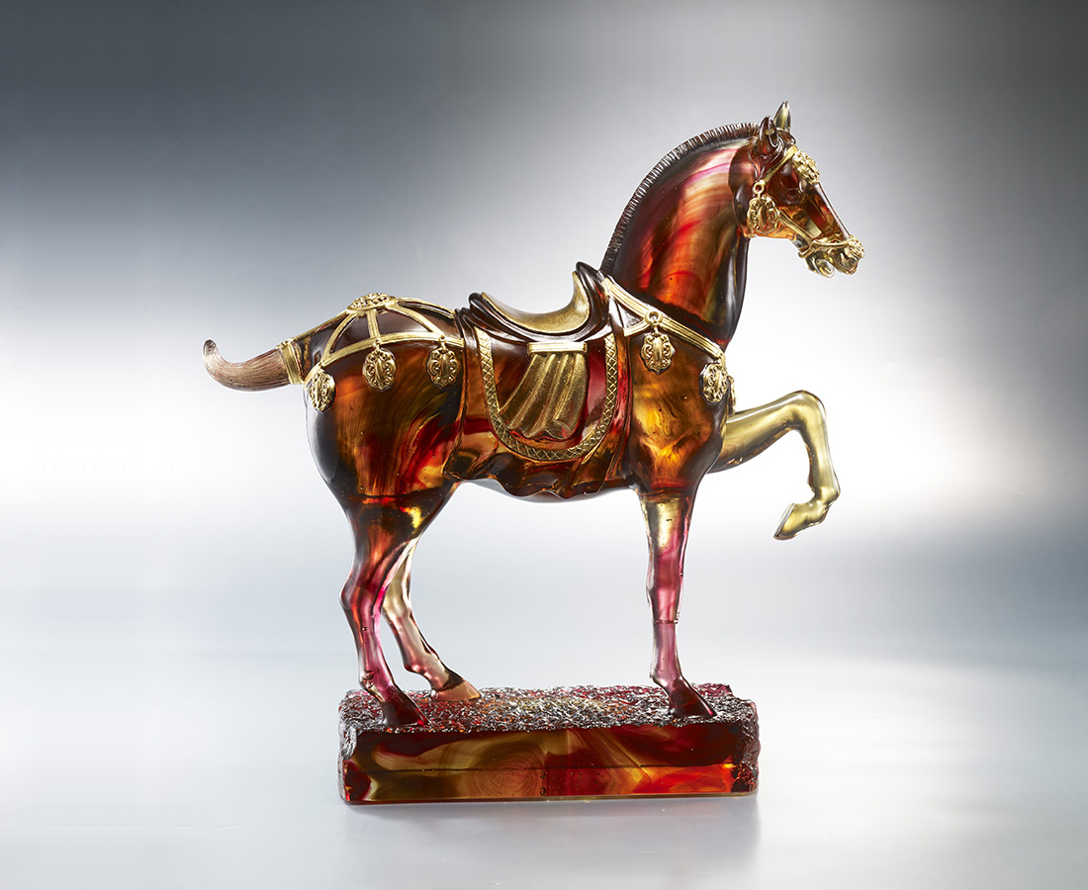
起始於堅韌之心志
成就於無瑕的修養
腳踏實地 一步步
踏上榮耀之階
Tricolor Horse of Tang Dynasty
Tittot takes the concept of the Tricolor Horse of the Tang Dynasty, using smooth colors to give perfect interpretation of the gorgeous Tricolor Horse, with a lifting front leg to add a sense of moving.

編號 | 1553669 | No | 1553669
名稱 | 榮耀登臨 | Name | Tricolor Horse of Tang Dynasty
顏色 | 金紅琥透＋金箔 | Color | golden, red, amber, clear + gold
尺寸 | 36.1 * 10.5 * 34.5 | Size | 36.1 * 10.5 * 34.5
重量 | 8.1 | Weight | 8.1
限量 | O | Limited Edition | O
售價 | NT$ 128000 | Price | NT$ 128000
 | RMB$ 28600 |  | RMB$ 28600

