意氣風發 | 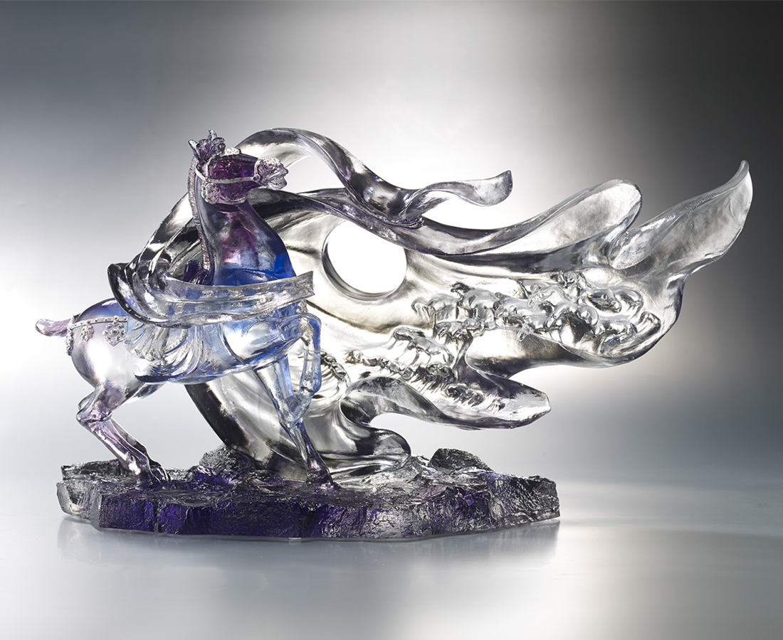
將大地立於眼前
每一個跨出都是夢想
將山川置於腳下
每一次騰躍都是堅持

Hero
Looking the mountain in distance from the peak, the horse is like its master placing vision afar while pondering directions for the future.

編號 | 1553668 | No | 1553668
名稱 | 意氣風發 | Name | Hero
顏色 | 藍紫灰透＋銀箔 | Color | blue, purple, grey, clear + silver
尺寸 | 49 * 20 * 27 | Size | 49 * 20 * 27
重量 | 9.9 | Weight | 9.9
限量 | O | Limited Edition | O
售價 | NT$ 88000 | Price | NT$ 88000
 | RMB$ 19550 |  | RMB$ 19550

