祿登青雲 | 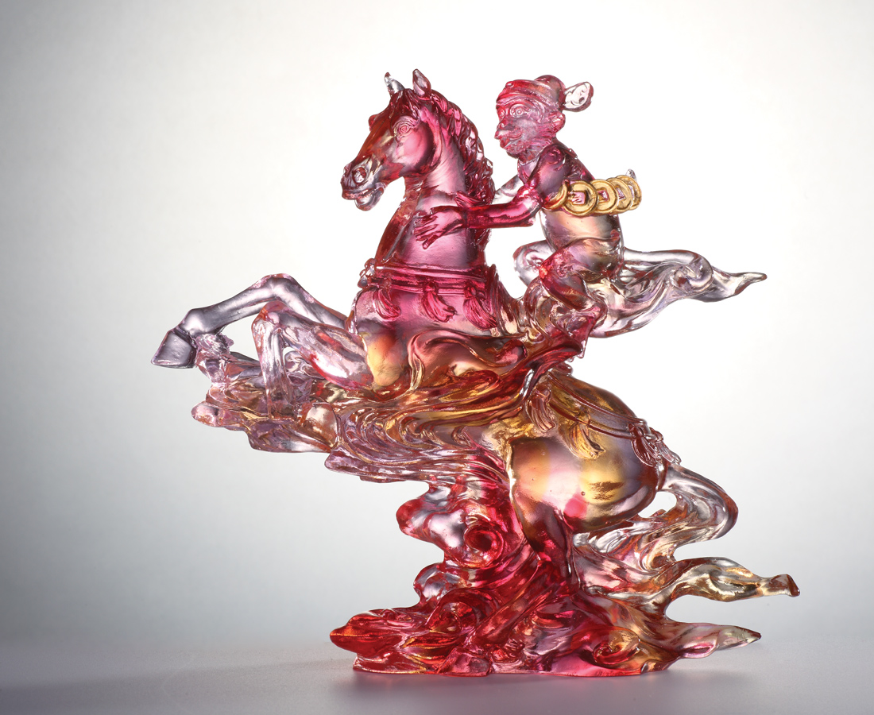
態度真誠 不屈不撓
風起雲湧 青雲直上
春風得意馬蹄急
一日看盡長安花
Decorations of Horse and Monkey
Tittot is inspired by the phrase "Ma Shang Feng Ho," which transliteration is a monkey on the horse, and the paraphrase is getting higher official status immediately. Happy monkey sitting on fast horses conveys the omen of coming happiness and good luck.

編號 | 1553632 | No | 1553632
名稱 | 祿登青雲 | Name | Decorations of Horse and Monkey
顏色 | 粉金紅 | Color | pink, golden, red
尺寸 | 18 * 8 * 19 | Size | 18 * 8 * 19
重量 | 1.16 | Weight | 1.16
限量 | O | Limited Edition | O
售價 | NT$ 16800 | Price | NT$ 16800
 | RMB$ 3740 |  | RMB$ 3740

