福自天申 | 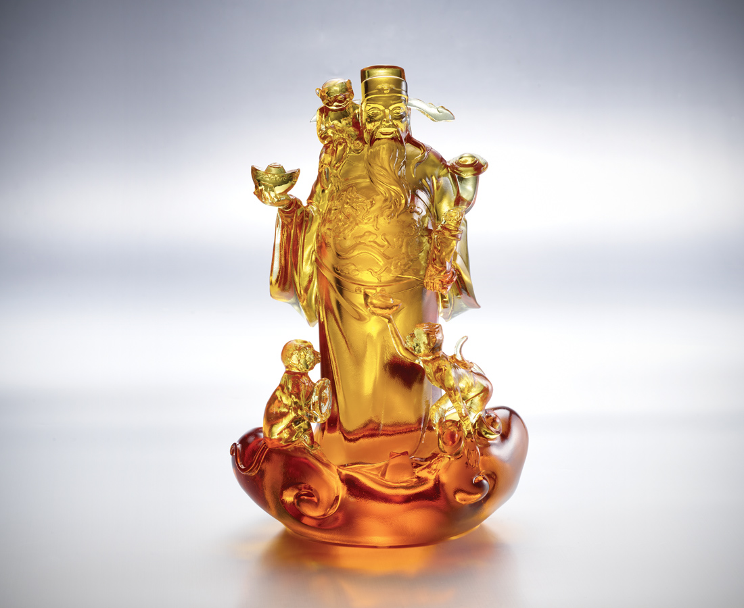
笑一笑
渾身如意似雲來
跳一跳
就能抓住好精采
層層疊疊 向上向前
福祿壽囍 從天而來
God of Wealth and Monkeys
The God of Wealth symbolizes money and luck in Chinese culture, and monkey represents power and status. The combination of the two implies all the wishes in the New Year can come true.

編號 | 1553613 | No | 1553613
名稱 | 福自天申 | Name | God of Wealth and Monkeys
顏色 | 琥 | Color | amber
尺寸 | 16.4 * 12 * 25.5 | Size | 16.4 * 12 * 25.5
重量 | 3.7 | Weight | 3.7
限量 | O | Limited Edition | O
售價 | NT$ 22800 | Price | NT$ 22800
 | RMB$ 5070 |  | RMB$ 5070

