同心 | 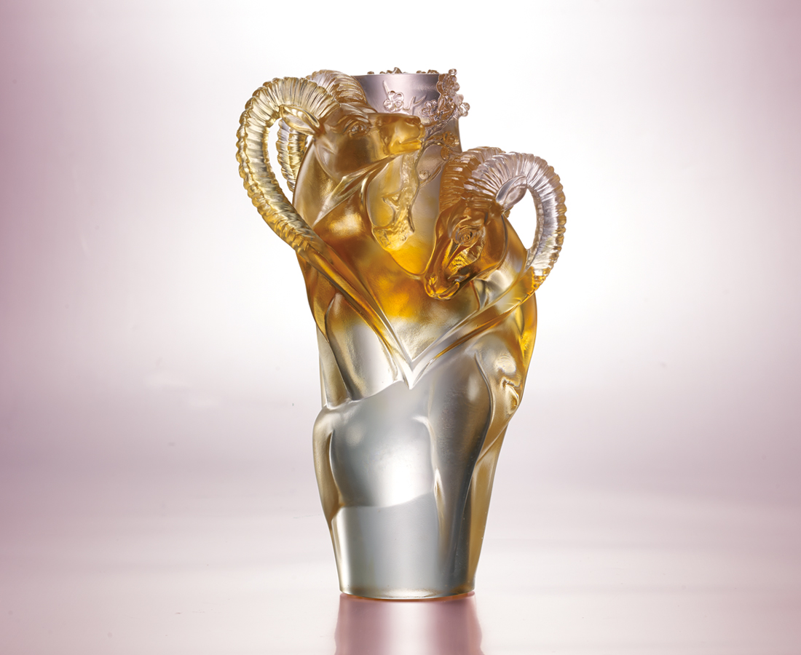
百鍊鋼 繞指柔
共用你我的真誠
天上人間 真心剔透
同心 何須言語
Accompanied heart
With the image of the two goats cuddling up to each other, Tittot wishes to show the most intimate affection between two people. The horns are bent into heart shape to symbolize the closeness and fidelity between husband and wife, parents and children.

編號 | 1553513 | No | 1553513
名稱 | 同心 | Name | Accompanied heart
顏色 | 粉紅琥透 | Color | pink, red, amber, clear
尺寸 | 13.7 * 9.4 * 22.8 | Size | 13.7 * 9.4 * 22.8
重量 | 2.6 | Weight | 2.6
限量 | O | Limited Edition | O
售價 | NT$ 12600 | Price | NT$ 12600
 | RMB$ 2800 |  | RMB$ 2800

