傲視群倫 | 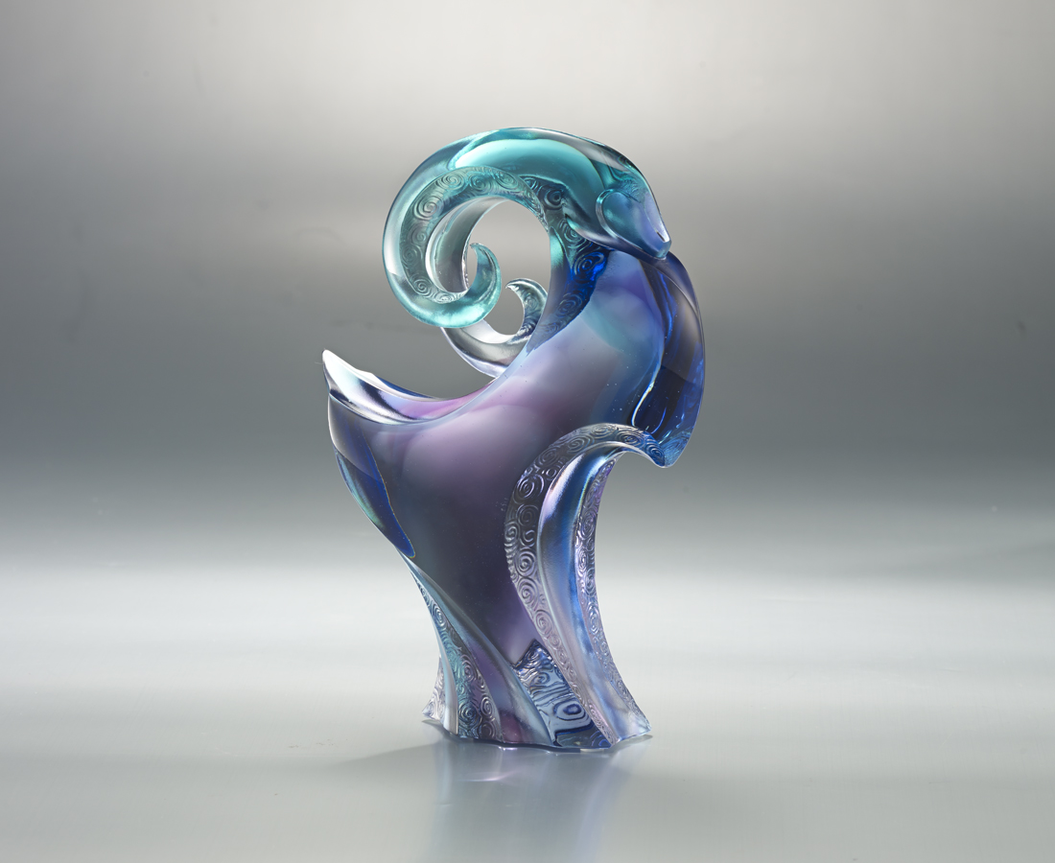
昂首 挺身
義無反顧的自覺
遠望 無懼
遼闊無盡的願景
以信心敲開世界
以實力傲視群倫
Confident Mien
Tittot transforms the goat into abstract lines to forge an upright posture as if it was a warrior full of confidence. It symbolizes that we should overcome adversities with courage and strength to create infinite opportunities. The art piece shows an elegant outline and stable posture that is only achievable with the superb technique of Tittot.

編號 | 1553512 | No | 1553512
名稱 | 傲視群倫 | Name | Confident Mien
顏色 | 藍青紫透 | Color | blue, cyan, purple, clear
尺寸 | 12.1 * 5.6 * 17.3 | Size | 12.1 * 5.6 * 17.3
重量 | 1.2 | Weight | 1.2
限量 | X | Limited Edition | X
售價 | NT$ 9450 | Price | NT$ 9450
 | RMB$ 2100 |  | RMB$ 2100

