躍揚 | 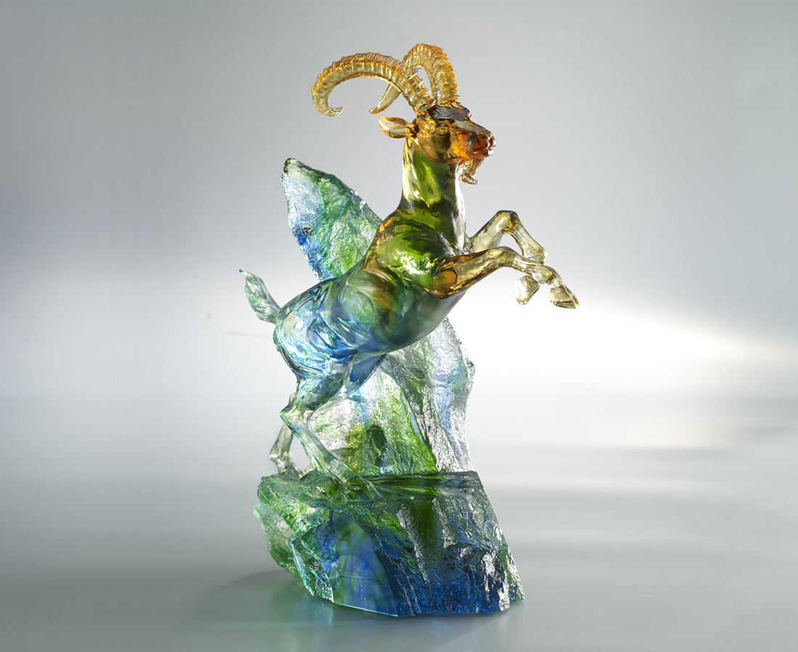
偉大夢想
在胸中躍動不止
高昂目標
在心裡翻騰不已
爆發出驚天動地的氣魄
一躍 就脫穎而出
Goat at the Peak
This Tittot artwork is themed as a goat jumping on the rocks. The goat is at the peak and its front hooves are lifted up. This art piece wishes to express that one should overcome adversities with perseverance to make progress and create a brand new future.

編號 | 1553504 | No | 1553504
名稱 | 躍揚 | Name | Goat at the Peak
顏色 | 琥藍綠透 | Color | blue, green, amber, clear
尺寸 | 25.4 * 15.2 * 36.5 | Size | 25.4 * 15.2 * 36.5
重量 | 9.2 | Weight | 9.2
限量 | O | Limited Edition | O
售價 | NT$ 38800 | Price | NT$ 38800
 | RMB$ 8620 |  | RMB$ 8620

