四禧呈祥 | 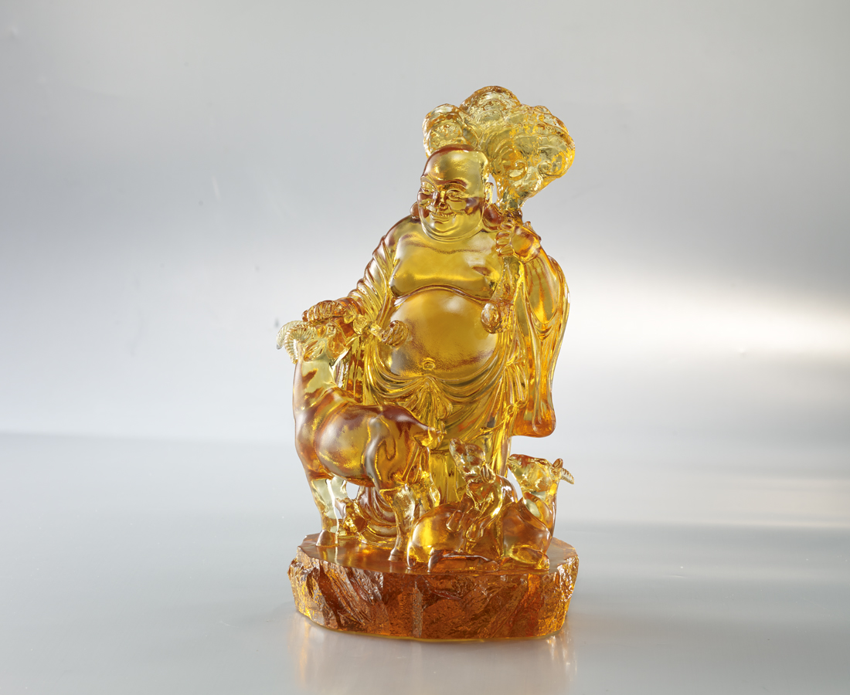
心寬種一生之福
謙虛受天賜之祿
知足享綿延之壽
泰然開無限之喜
Maitreya Buddha and Sheep
The smiling Maitreya Buddha always brings us joy. Together with the auspicious sheep, which is a homophone for “Jixiang (auspicious)” in China, the Maitreya Buddha brings everyone with fortune and happiness.

編號 | 1553484 | No | 1553484
名稱 | 四禧呈祥 | Name | Maitreya Buddha and Sheep
顏色 | 金琥透 | Color | golden, amber, clear
尺寸 | 13.9 * 15.2 * 24.5 | Size | 13.9 * 15.2 * 24.5
重量 | 4.0 | Weight | 4.0
限量 | O | Limited Edition | O
售價 | NT$ 23800 | Price | NT$ 23800
 | RMB$ 5290 |  | RMB$ 5290

