巔峰(的盧) | 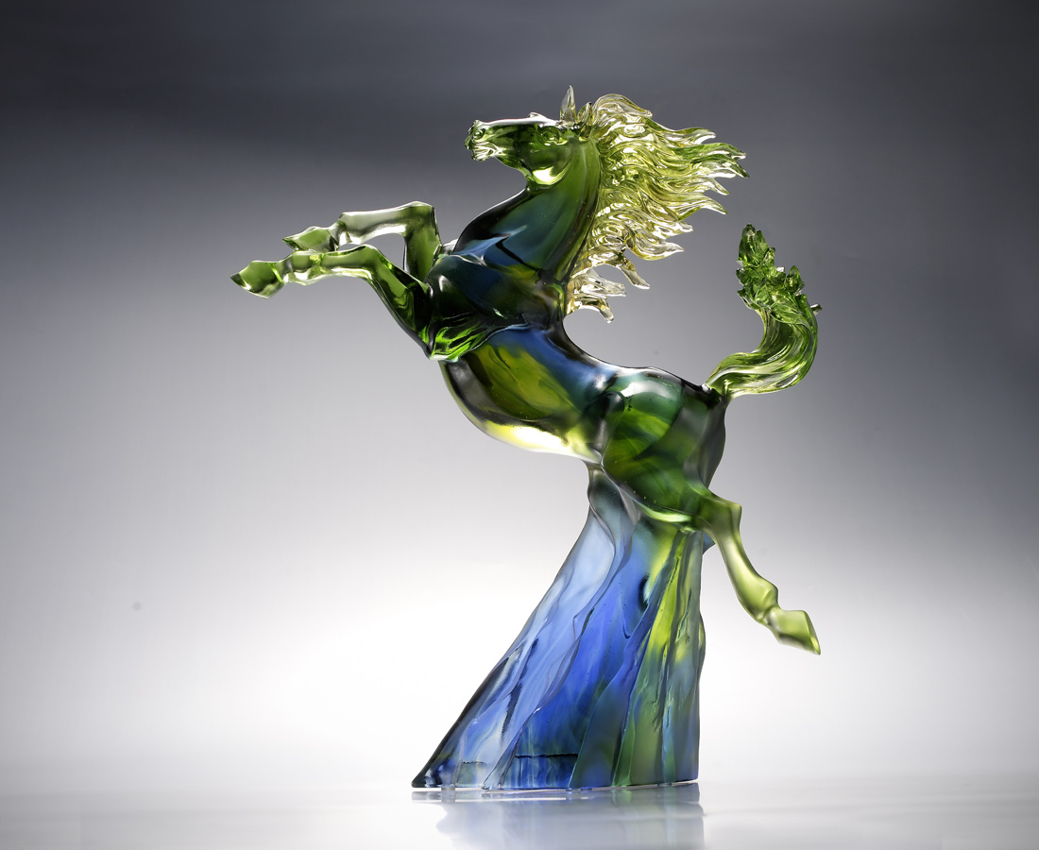
面對困境艱險
我就用雙足突破
跨越頂峰
奔向更高處
踏破天下
The Peak
The mountain-shaped base represents adversities in life, while the horse jumping over the mountain symbolizes overcoming adversities and creating opportunities.

編號 | 1553354 | No | 1553354
名稱 | 巔峰(的盧) | Name | The Peak
顏色 | 藍綠透 | Color | null
尺寸 | 28 * 12 * 33 | Size | 28 * 12 * 33
重量 | 4.4 | Weight | 4.4
限量 | O | Limited Edition | O
售價 | NT$ 45770 | Price | NT$ 45770
 | RMB$ 8850 |  | RMB$ 8850

