騰躍四海(白龍馬) | 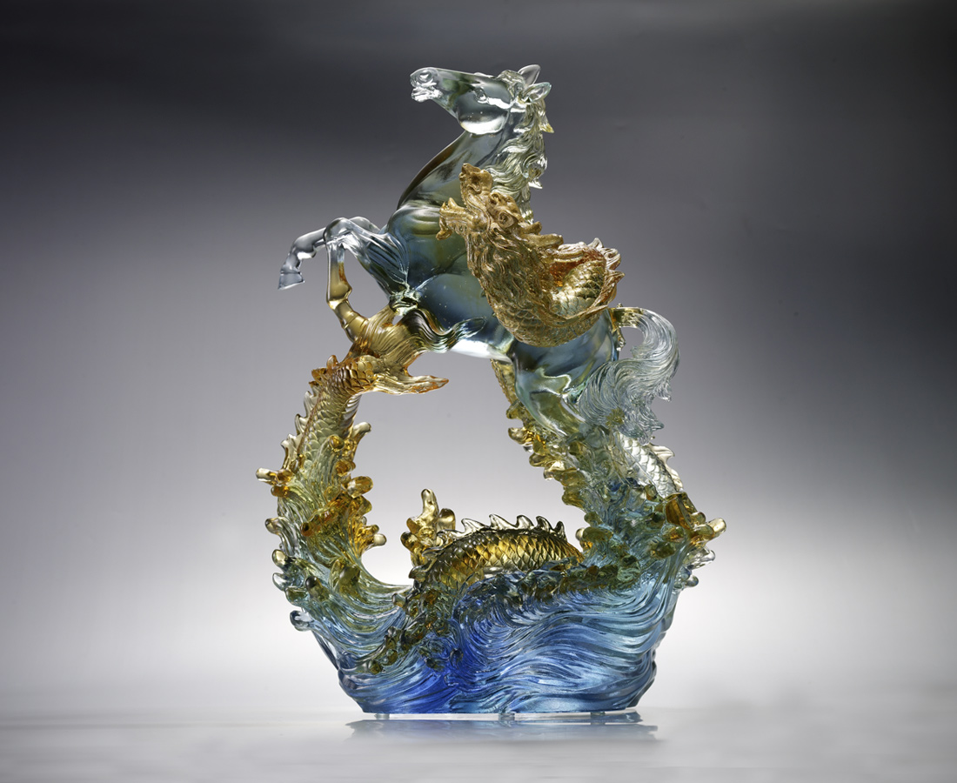
穿越重重考驗
遊於千山萬水
誰說馬只在草原
偏奔馳於驚濤駭浪之上
嘯聲是開疆拓土的呼應
踢踏成不可一世的氣概
The Curveting Steed
The strength and vitality of a horse and dragon stand for talents that shall not be confined to any situation. When the time comes, one shall spare no effort in demonstrating his talent.

編號 | 1553330 | No | 1553330
名稱 | 騰躍四海(白龍馬) | Name | The Curveting Steed
顏色 | 藍青琥透+金箔 | Color
尺寸 | 29.3 * 20.3 * 39.7 | Size | 29.3 * 20.3 * 39.7
重量 | 10.8 | Weight | 10.8
限量 | O | Limited Edition | O
售價 | NT$ 150480 | Price | NT$ 150480
 | RMB$ 33440 |  | RMB$ 33440

