獨領風騷(爪黃飛電) | 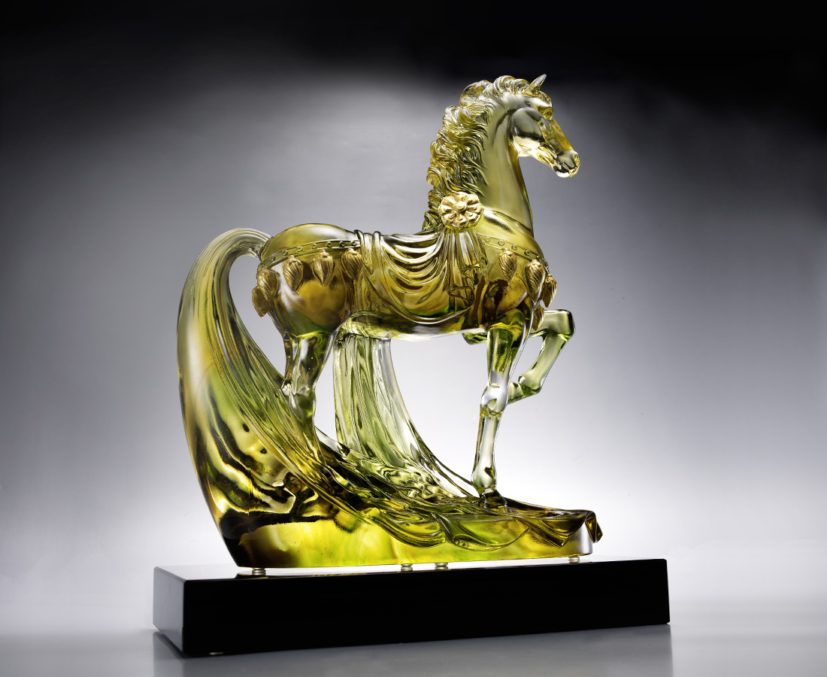
態度決定高度
轉身 昂然自得
踏足 氣度雍容
放眼天下 絕不流俗
唯我 獨領風騷
Sole Domination
This artwork representing the strong and confident horse of ancient Chinese generals, symbolizes that confidence empowers every move with leadership momentum.

編號 | 1553327 | No | 1553327
名稱 | 獨領風騷(爪黃飛電) | Name | Sole Domination
顏色 | 金茶綠透+金箔 | Color | gold, brown, green, clear
尺寸 | 28 * 13.5 * 33.5 | Size | 28 * 13.5 * 33.5
重量 | 8.3 | Weight | 8.3
限量 | O | Limited Edition | O
售價 | NT$ 116600 | Price | NT$ 116600
 | RMB$ 25900 |  | RMB$ 25900

