逆風健行(夜照玉獅子) | 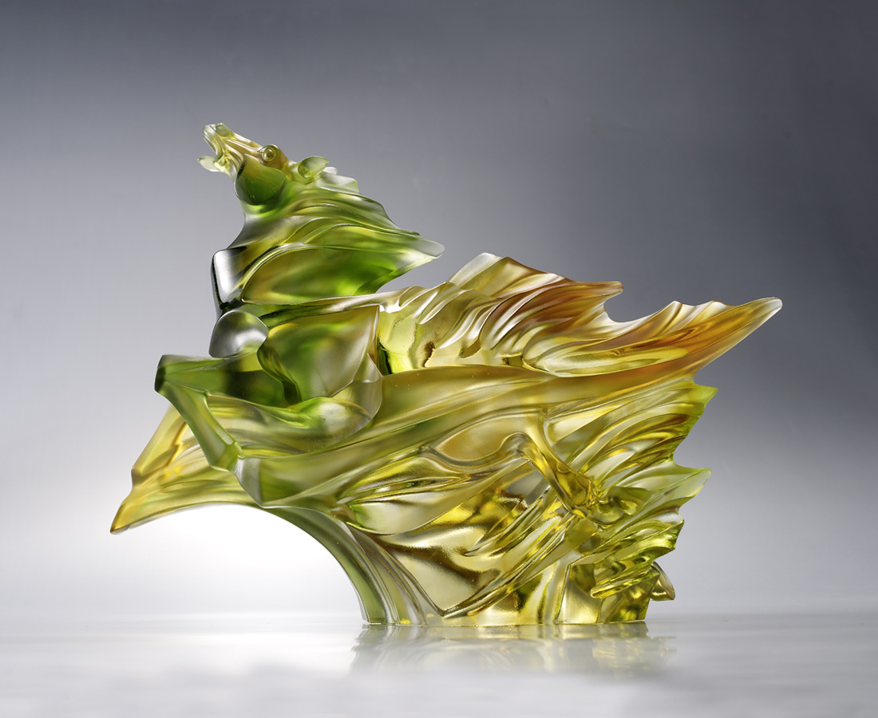
天行健 君子以自強不息
在逆風之時更要邁進
把障礙像塵埃般遠拋在後
必將立於風頭之上
Galloping against the Wind
It is said that horses usually run against the wind. In this artwork, the horse gallops against the wind and it symbolizes man’s tenacious and indomitable spirit that can overcome adversities.

編號 | 1553319 | No | 1553319
名稱 | 逆風健行(夜照玉獅子) | Name | Galloping against the Wind
顏色 | 琥綠透 | Color
尺寸 | 32.7 * 11.5 * 24.7 | Size | 32.7 * 11.5 * 24.7
重量 | 5.7 | Weight | 5.7
限量 | O | Limited Edition | O
售價 | NT$ 46800 | Price | NT$ 46800
 | RMB$ 10400 |  | RMB$ 10400

