成功在望(赤兔馬) | 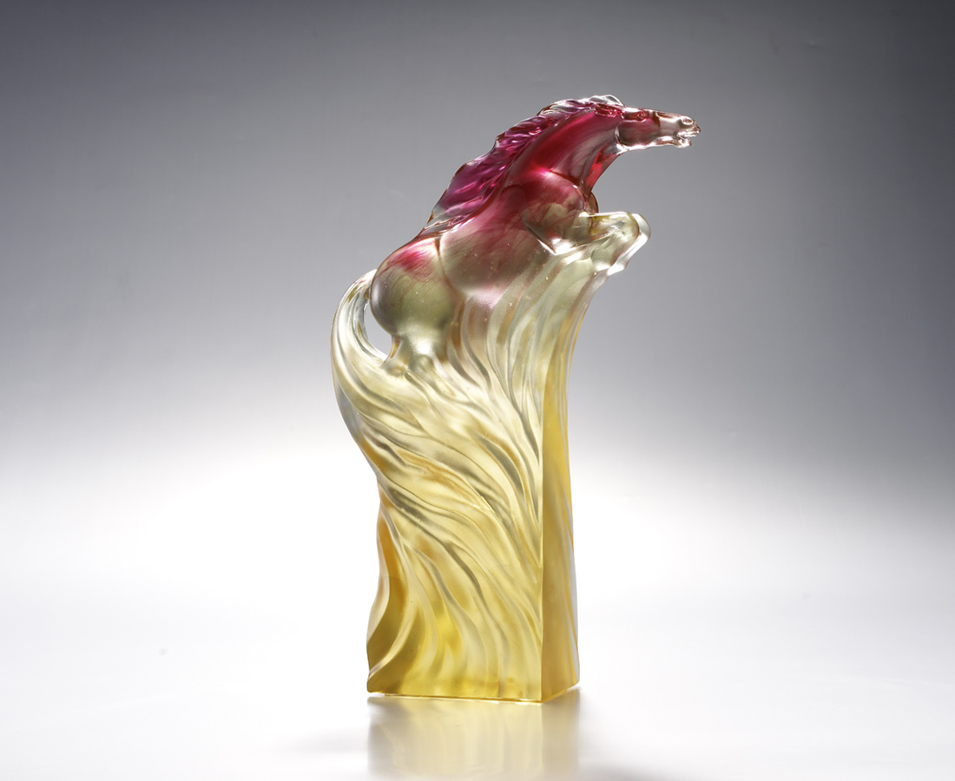
千里奔馳
是永不屈服的決心
萬古流芳
是鍥而不捨的毅力
全力躍起
成功 當然在望
Victory within Reach
The form of Guan Gong’s mount, Red Rabbit horse galloping forward is a manifesto of courage and perseverance of the legendary strength forged by countless challenges and tests. It is unstoppable with its name echoing in eternity.

編號 | 1553288 | No | 1553288
名稱 | 成功在望(赤兔馬) | Name | Victory within Reach
顏色 | 金紅綠透 | Color
尺寸 | 6.3 * 17.8 * 26.9 | Size | 6.3 * 17.8 * 26.9
重量 | 2.39 | Weight | 2.39
限量 | O | Limited Edition | O
售價 | NT$ 17800 | Price | NT$ 17800
 | RMB$ 3950 |  | RMB$ 3950

