喜慶滿載 | 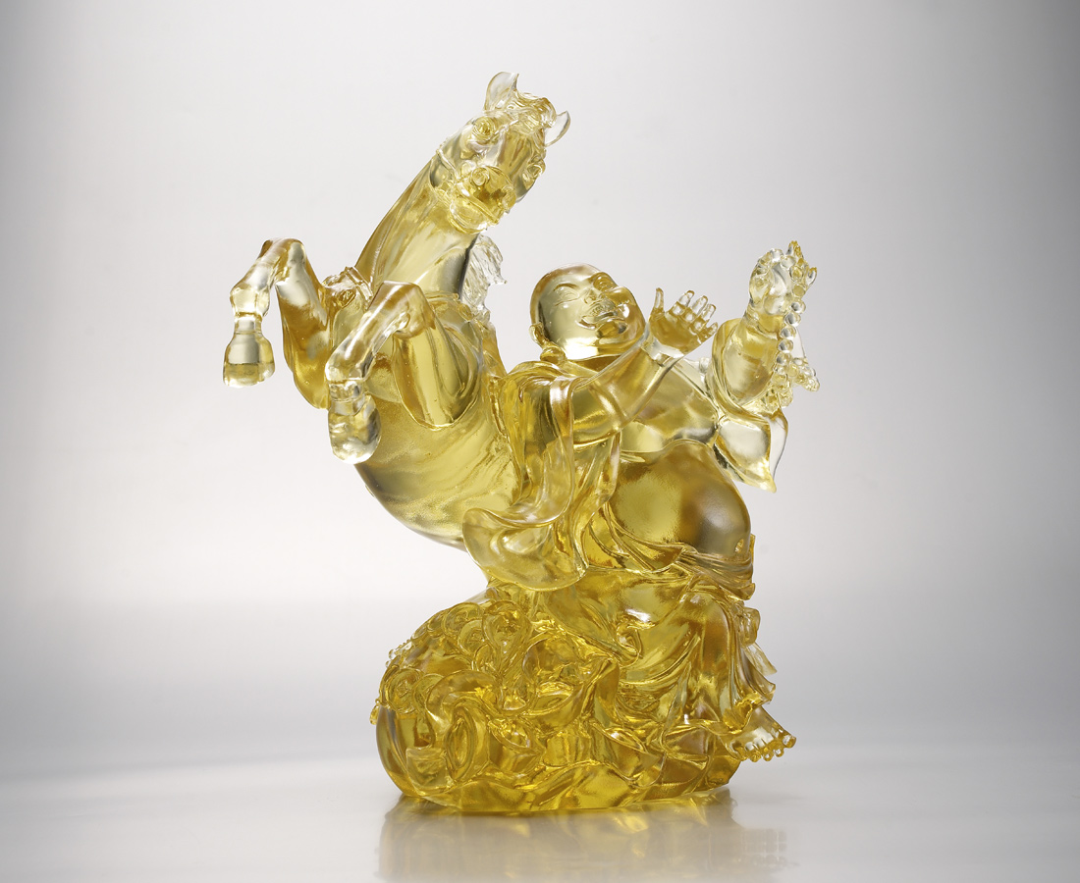
馬蹄達達 歌聲響亮
自信從容 得心應手
喜悅滿載 功成名就
Full of Happiness
The joyful Maitreya Buddha is singing and clapping with the jumping horse, symbolizing a free mind at ease to face everything with confidence and heralding the arrival of happiness, blessings and wealth.

編號 | 1553283 | No | 1553283
名稱 | 喜慶滿載 | Name | Full of Happiness
顏色 | 金 | Color
尺寸 | 17 * 23 * 24.5 | Size | 17 * 23 * 24.5
重量 | 5.5 | Weight | 5.5
限量 | X | Limited Edition | X
售價 | NT$ 27800 | Price | NT$ 27800
 | RMB$ 6170 |  | RMB$ 6170

