暢享四季 | 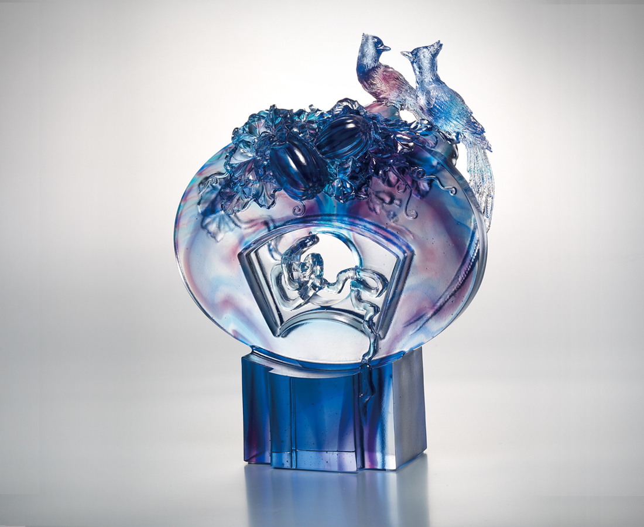
坐看青山不移
都說花開結果
朗朗高志 胸有成竹
雙飛雙舞千里來
唱響四季春常在
Joyful Seasons
As firm as the unshakeable mountains As blossoming and fruitful as the flowers Our wills aim high Our confidence never dies Paradise Flycatchers always come in pairs Sing spring at all seasons

編號 | 1553249 | No | 1553249
名稱 | 暢享四季 | Name | Joyful Seasons
顏色 | 藍青紫透 | Color
尺寸 | 10.3 * 18.5 * 23.8 | Size | 10.3 * 18.5 * 23.8
重量 | 2.68 | Weight | 2.68
限量 | O | Limited Edition | O
售價 | NT$ 18800 | Price | NT$ 18800
 | RMB$ 2480 |  | RMB$ 2480

