龍騰運轉 | 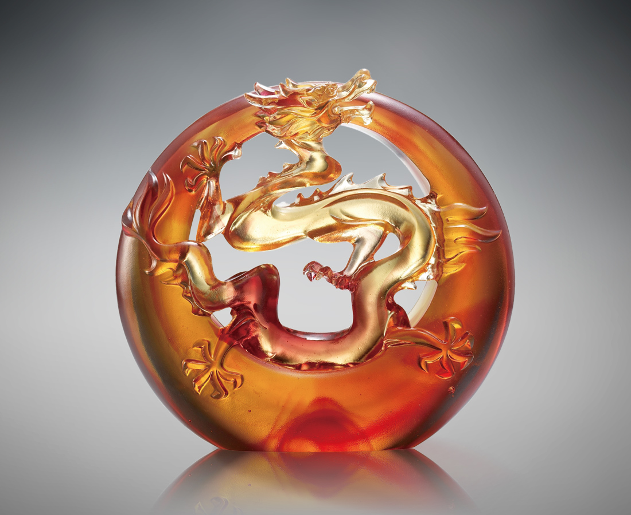
天也高 地也寬
好把身手全力舞
是果決 也包容
豁然洞開功名揚
Everlasting Luck for the Soaring Dragon
With high heavens and the broad earth Opportunities abound everywhere to display one’s talents With decisive action and a generous mind Fame is just within arm’s reach with your contribution to the world

編號 | 1553212 | No | 1553212
名稱 | 龍騰運轉 | Name | Everlasting Luck for the Soaring Dragon
顏色 | 金綠 / 琥紅 | Color | null
尺寸 | 15 * 14.3 * 5 | Size | 15 * 14.3 * 5
重量 | 1.4 | Weight | 1.4
限量 | O | Limited Edition | O
售價 | NT$ 12750 | Price | NT$ 12750
 | RMB$ 2830 |  | RMB$ 2830

