龍耀中天 | 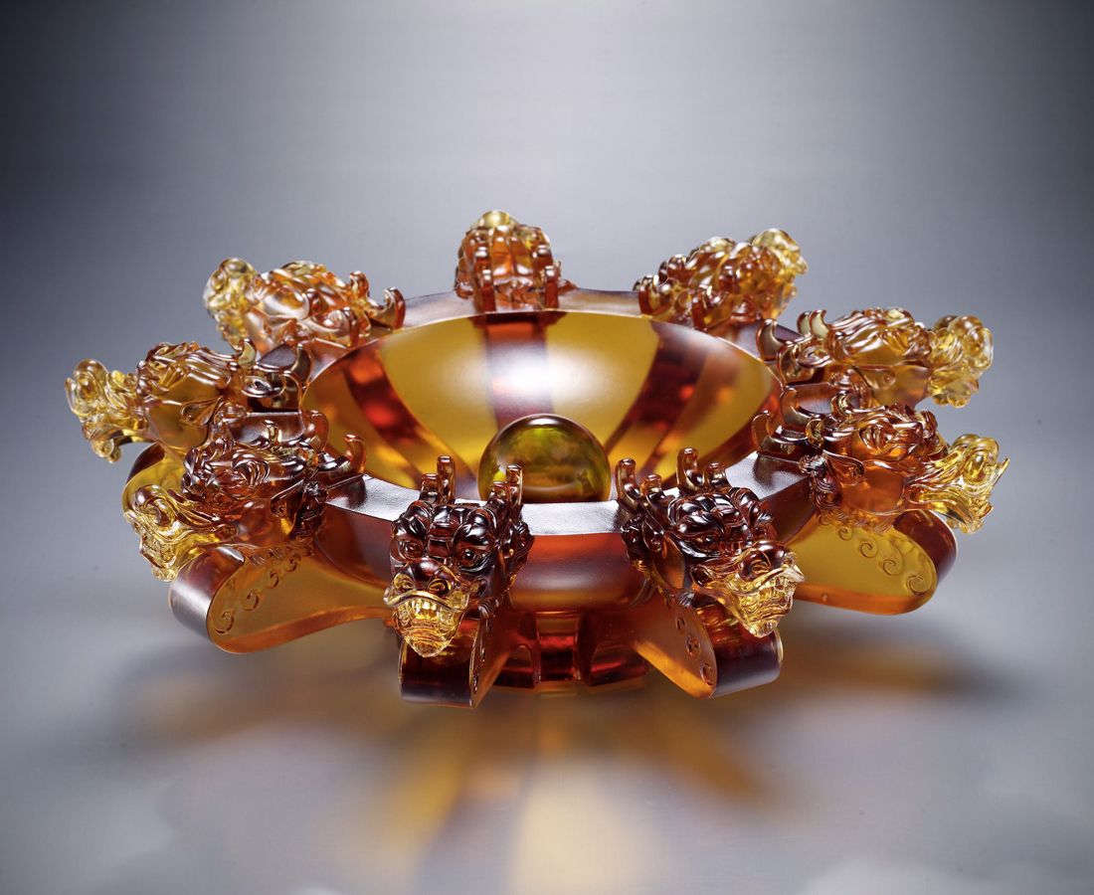
舀一瓢盛唐明月
狂飲一江大漢水
闖繼往開來英雄夢
圓精誠團結理想國
Dragon Dome of the Sky
Profoundly, ladle the bright moon Aggressively, guzzle down the river water Go beyond your heroic dreams And open up the way towards the future And realize the utopia built with the aid of unity

編號 | 1553211 | No | 1553211
名稱 | 龍耀中天 | Name | Dragon Dome of the Sky
顏色 | 琥 | Color | null
尺寸 | 33 * 33 * 11 | Size | 33 * 33 * 11
重量 | 7.4 | Weight | 7.4
限量 | O | Limited Edition | O
售價 | NT$ 55800 | Price | NT$ 55800
 | RMB$ 12380 |  | RMB$ 12380

