氣運生輝 | 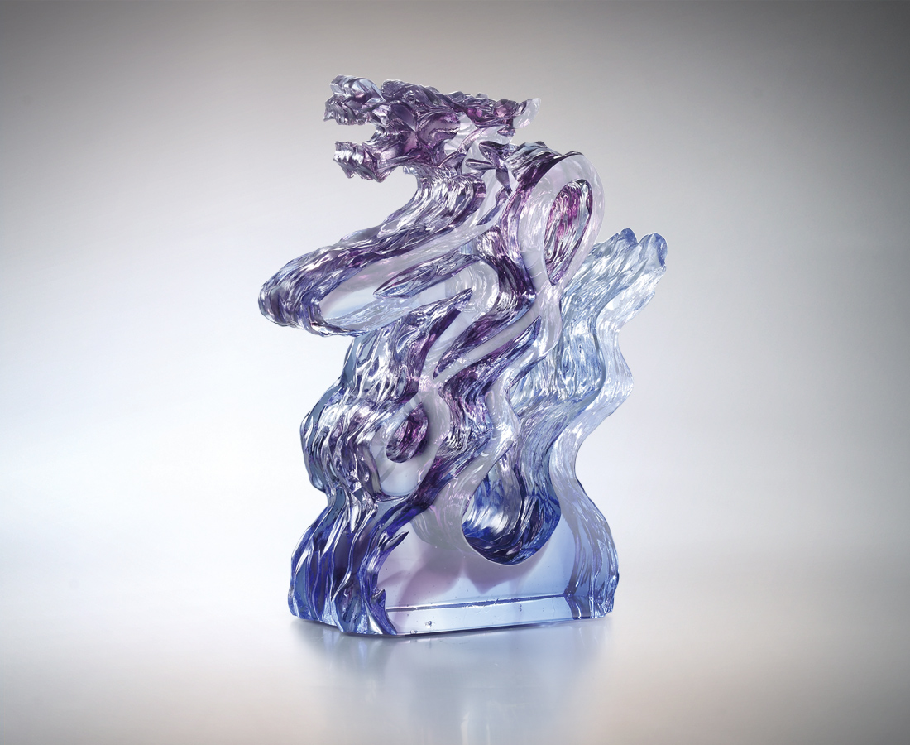
多少風浪鐫刻的瀟灑
把氣聚內 勢如雷動
把心放下 行如電掣
即縱意所如馳萬里
無所不至而耀天下
Qi Dancing into the Light
Ease out of countless hardships Thunders with an overwhelming aura The eased heart is lightning quick The unbound mind travels thousands of miles in no time Touching everything with its bright shine

編號 | 1553190 | No | 1553190
名稱 | 氣運生輝 | Name | Qi Dancing into the Light
顏色 | 藍紫透 | Color | blue, purple, clear
尺寸 | 4.9 * 11.2 * 15.1 | Size | 4.9 * 11.2 * 15.1
重量 | 0.85 | Weight | 0.85
限量 | X | Limited Edition | X
售價 | NT$ 8700 | Price | NT$ 8700
 | RMB$ 1950 |  | RMB$ 1950

