肝膽相照(2013) | 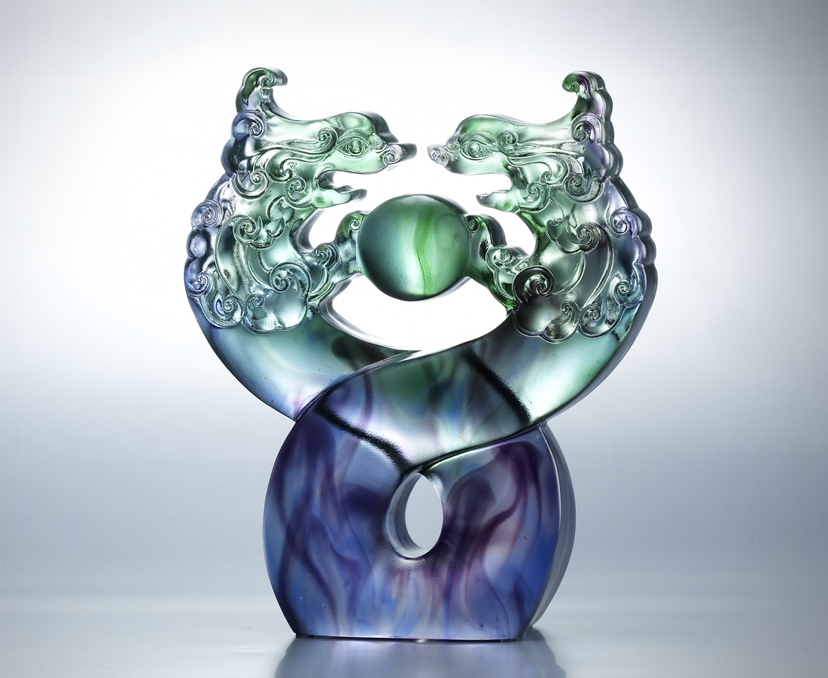
英雄忠誠 明鑑照人
好漢英勇 繼往開來
回首 相輔相成
相對 棋逢好手
誠心繫手 互助合作
相惜相知 肝膽相照
祥雲紛飛 功業蓋天
Treat One Another With Sincerity
Heroism and honesty shine radiantly Great men and heroes throughout the ages Recollecting and complementing one another Rising to the challenge, meeting their match Standing united, working in collaboration Cherishing one another, treating one another with sincerity Auspicious clouds floating in the sky, filled with a sense of success.

編號 | 1553187 | No | 1553187
名稱 | 肝膽相照(2013) | Name | Treat One Another With Sincerity
顏色 | 藍綠紫透 | Color
尺寸 | 18 * 7 * 21.2 | Size | 18 * 7 * 21.2
重量 | 2.8 | Weight | 2.8
限量 | X | Limited Edition | X
售價 | NT$ 18800 | Price | NT$ 18800
 | RMB$ 4722 |  | RMB$ 4722

