錠天下 | 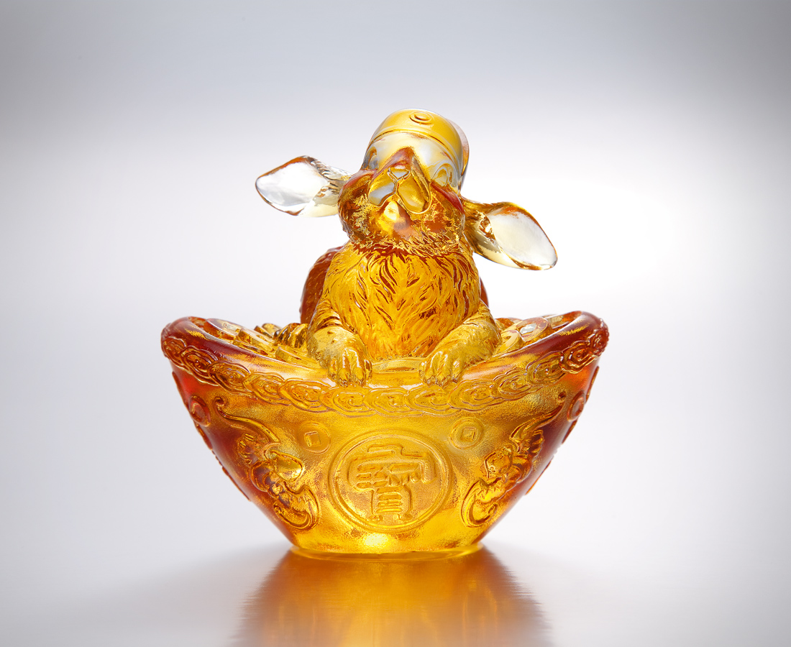
立穩如泰山寶地
堅定 再堅定
聽從東到西風雲
登高 再登高
一露臉就贏滿堂彩
World of Prosperity
Standing firmly on the land of treasures Steady and solid as a rock Gathering intelligence from all directions Standing tall and straight Success is guaranteed for every endeavor

編號 | 1552956 | No | 1552956
名稱 | 錠天下 | Name | World of Prosperity
顏色 | 琥透 | Color
尺寸 | 7.8 * 10.7 * 10.5 | Size | 7.8 * 10.7 * 10.5
重量 | 1.1 | Weight | 1.1
限量 | X | Limited Edition | X
售價 | NT$ 5880 | Price | NT$ 5880
 | RMB$ 1300 |  | RMB$ 1300

