緣滿如意 | 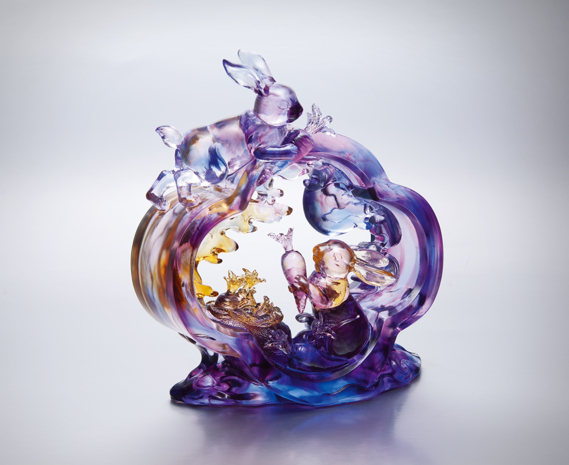
賞月耕採 雲水悠遊
順節氣而行 時時豐收
留朋呼友 歡會宴喜
伴真情而享 事事如意
Abundant Success
Whether admiring the moon, cultivating Or appreciating the drifting cloud and water Through the rhythm of the changing seasons Abundant harvest can be reaped Share the fruitfulness with others Happiness and prosperity shall be even more prolific

編號 | 1552954 | No | 1552954
名稱 | 緣滿如意 | Name | Abundant Success
顏色 | 藍紫粉琥透 | Color | blue, purple, pink, amber, clear
尺寸 | 8.4 * 18 * 19.7 | Size | 8.4 * 18 * 19.7
重量 | 1.9 | Weight | 1.9
限量 | O | Limited Edition | O
售價 | NT$ 15860 | Price | NT$ 15860
 | RMB$ 3550 |  | RMB$ 3550

