富貴天成 | 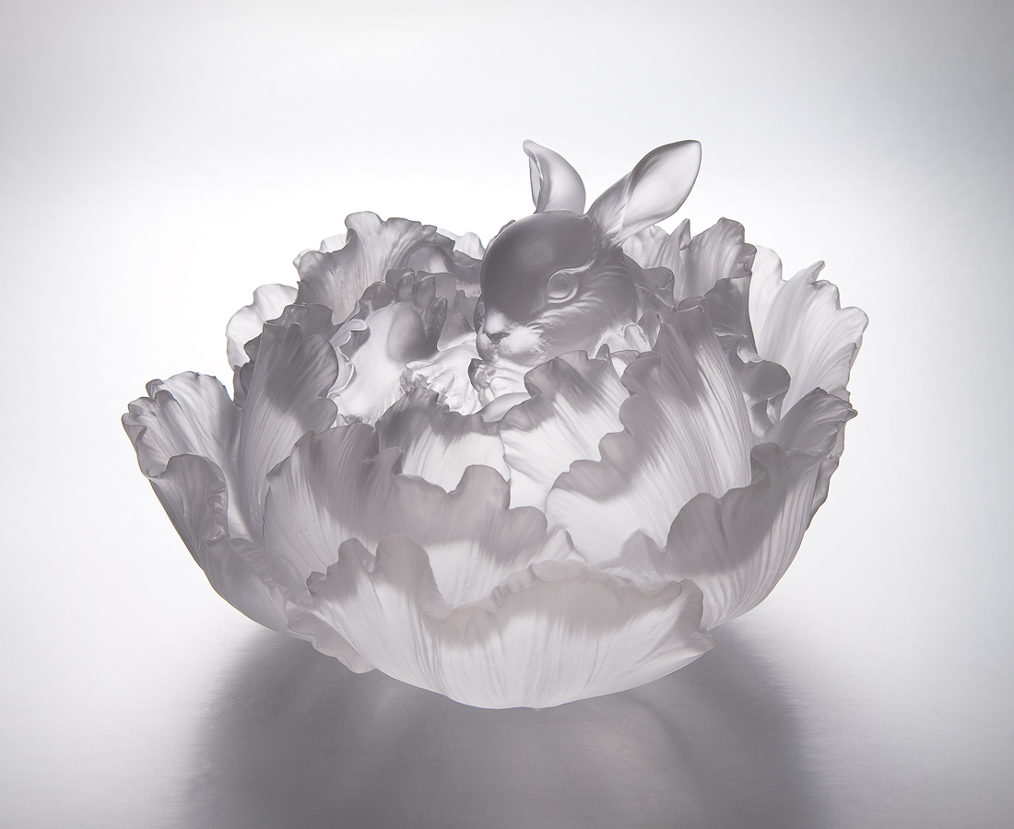
關不住春滿希望
藏不盡情真意好
染一身花團錦簇
一生常在富貴中
Birth of Fortune and Prosperity
Blossoming hope of spring season The purity and innocence of the new born Encompassed in abundant fortune and prosperity Enjoying success of a lifetime

編號 | 1552928 | No | 1552928
名稱 | 富貴天成 | Name | Birth of Fortune and Prosperity
顏色 | 透(噴砂) | Color
尺寸 | 13.6 * 13.2 * 9 | Size | 13.6 * 13.2 * 9
重量 | 1.4 | Weight | 1.4
限量 | X | Limited Edition | X
售價 | NT$ 6880 | Price | NT$ 6880
 | RMB$ 1520 |  | RMB$ 1520

