月望圓滿 | 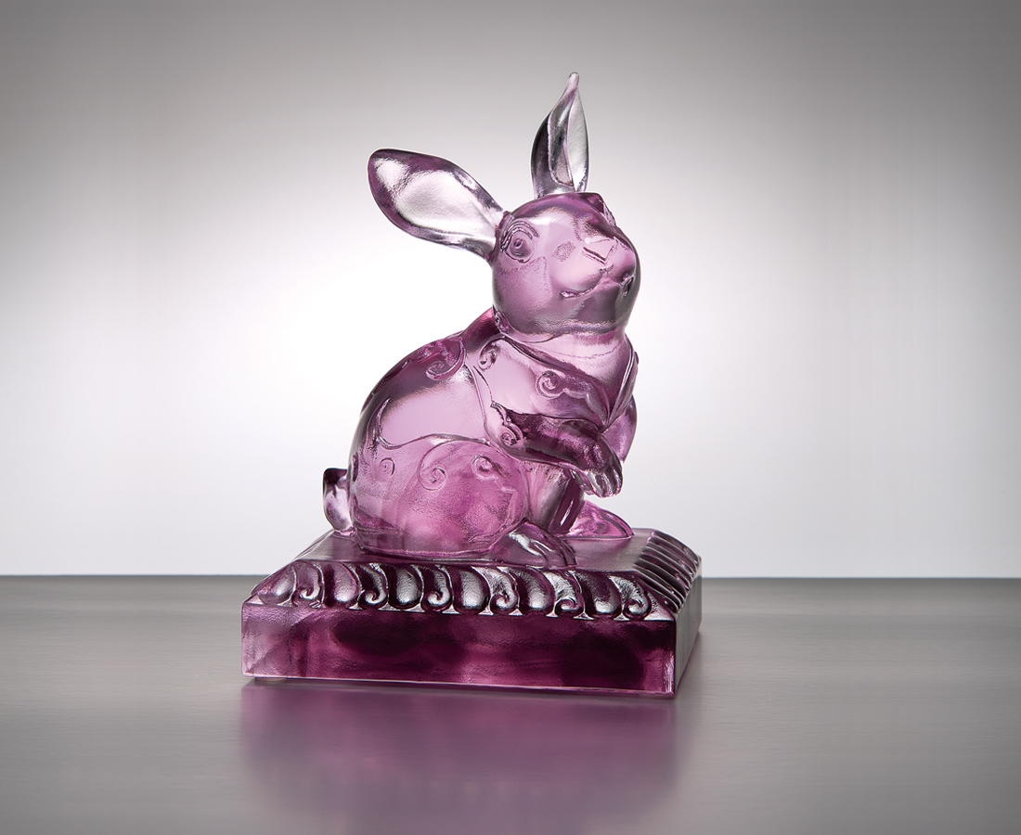
不關風 只向月
照天地有情處處光明
映春夏秋冬花好人好
而願望圓滿 共好夢
Full Moon Perfection
The omnipresent friendship and warmth Reflecting wonderful bliss of the four seasons Fulfilling every desire and heartfelt wishes

編號 | 1552914 | No | 1552914
名稱 | 月望圓滿 | Name | Full Moon Perfection
顏色 | 粉紫透 | Color
尺寸 | 7 * 9 * 12.3 | Size | 7 * 9 * 12.3
重量 | 1.3 | Weight | 1.3
限量 | X | Limited Edition | X
售價 | NT$ 4960 | Price | NT$ 4960
 | RMB$ 1120 |  | RMB$ 1120

