一嘯定天下 | 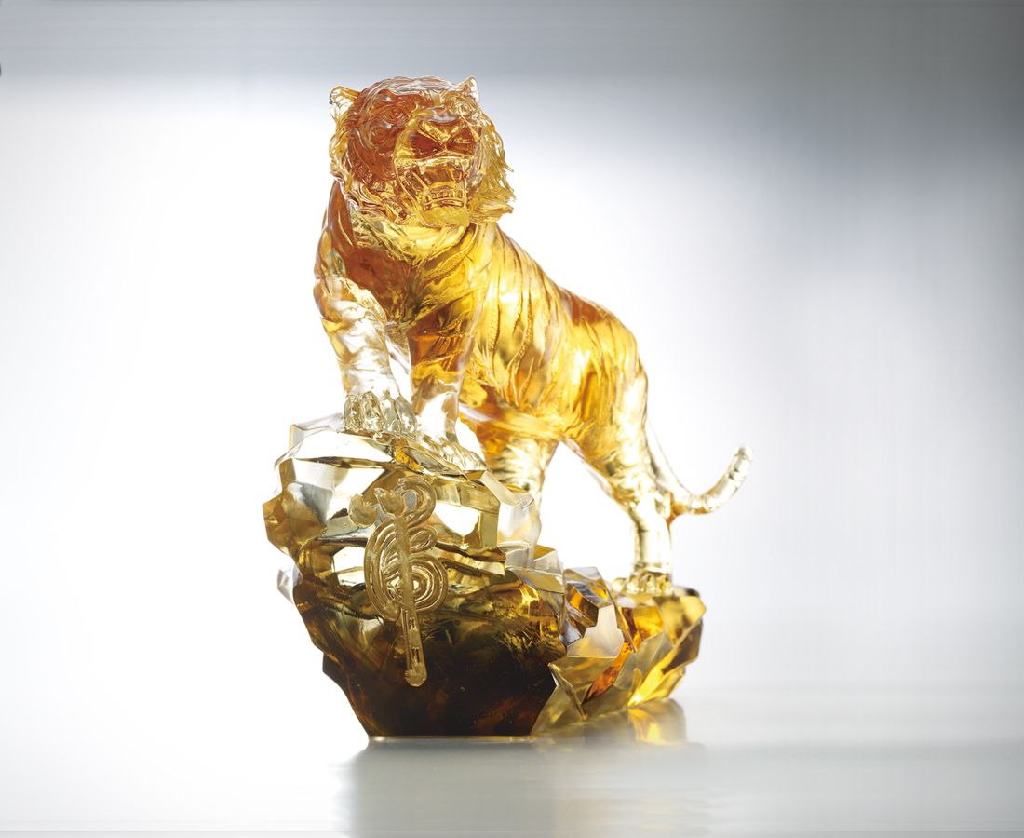
帶奔雷之勢
上高山之巔
迎大時代浪潮
一嘯谷風生
Roar of Triumph
With the fearsome force of a roaring thunder The tiger heads straight for the mountaintop Keeping abreast with the tides of change A ferocious roar Brings success and prosperity

編號 | 1552827 | No | 1552827
名稱 | 一嘯定天下 | Name | Roar of Triumph
顏色 | 金灰透 | Color | null
尺寸 | 15 * 24 * 24 | Size | 15 * 24 * 24
重量 | 5.2 | Weight | 5.2
限量 | O | Limited Edition | O
售價 | NT$ 36168 | Price | NT$ 36168
 | RMB$ 6600 |  | RMB$ 6600

