飛虎福將 | 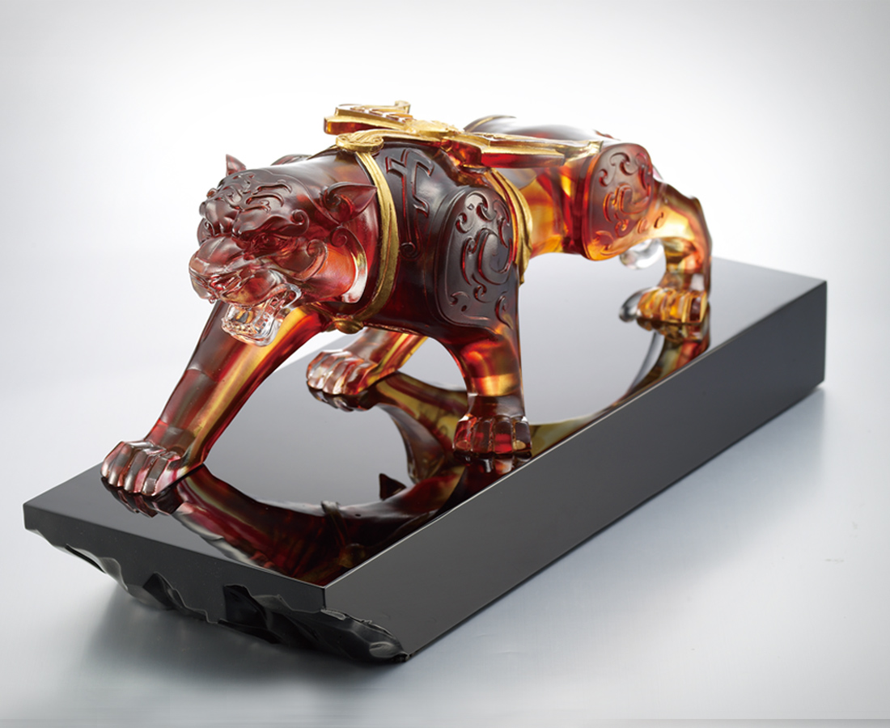
風 火
錘鍊無堅不摧的戰甲
山 林
蓄勢如虎添翼的信心
一躍 就是雷霆萬鈞
Winged Tiger
Armed with indestructible armor Forged by the wind and fire As well as overwhelming audacity Bestowed by the mountain and forest The tiger with wings Leaps forward with thunderous force

編號 | 1552820 | No | 1552820
名稱 | 飛虎福將 | Name | Winged Tiger
顏色 | 琥紅透+底座:黑 | Color
尺寸 | 15.6 * 40.3 * 19.4 | Size | 15.6 * 40.3 * 19.4
重量 | 14.7 | Weight | 14.7
限量 | O | Limited Edition | O
售價 | NT$ 68800 | Price | NT$ 68800
 | RMB$ 13800 |  | RMB$ 13800

