招財虎 | 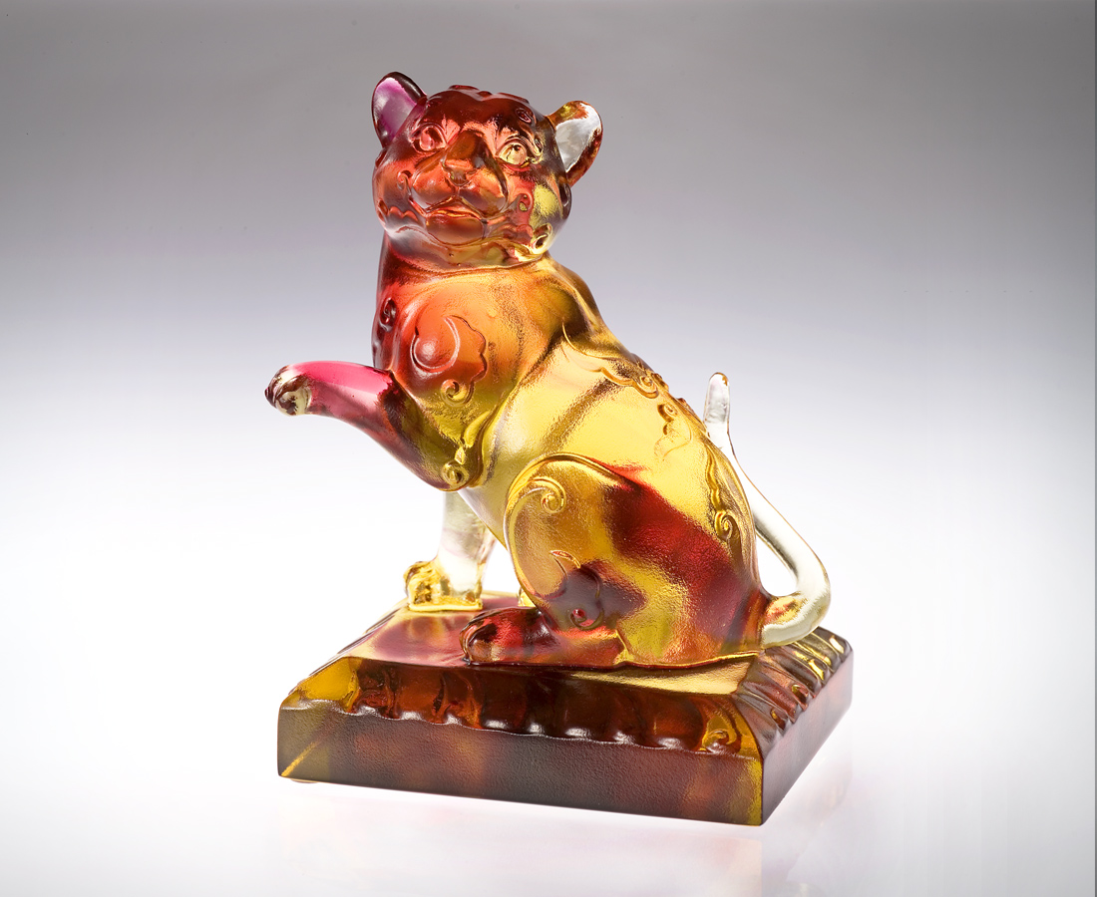
向夢想源頭探索
滿眼希望招樂觀進取
滿腔熱望招全心投入
堅持到底 招財進福
Tiger of Fortune
Seeking the origin of true happiness Full of hope and optimism Abundant in aspiration and commitment Persevere to the end And fortune shall be forthcoming

編號 | 1552817 | No | 1552817
名稱 | 招財虎 | Name | Tiger of Fortune
顏色 | 金紅 | Color
尺寸 | 6.8 * 9.2 * 10.2 | Size | 6.8 * 9.2 * 10.2
重量 | 0.6 | Weight | 0.6
限量 | X | Limited Edition | X
售價 | NT$ 4980 | Price | NT$ 4980
 | RMB$ 1100 |  | RMB$ 1100

