好福氣 | 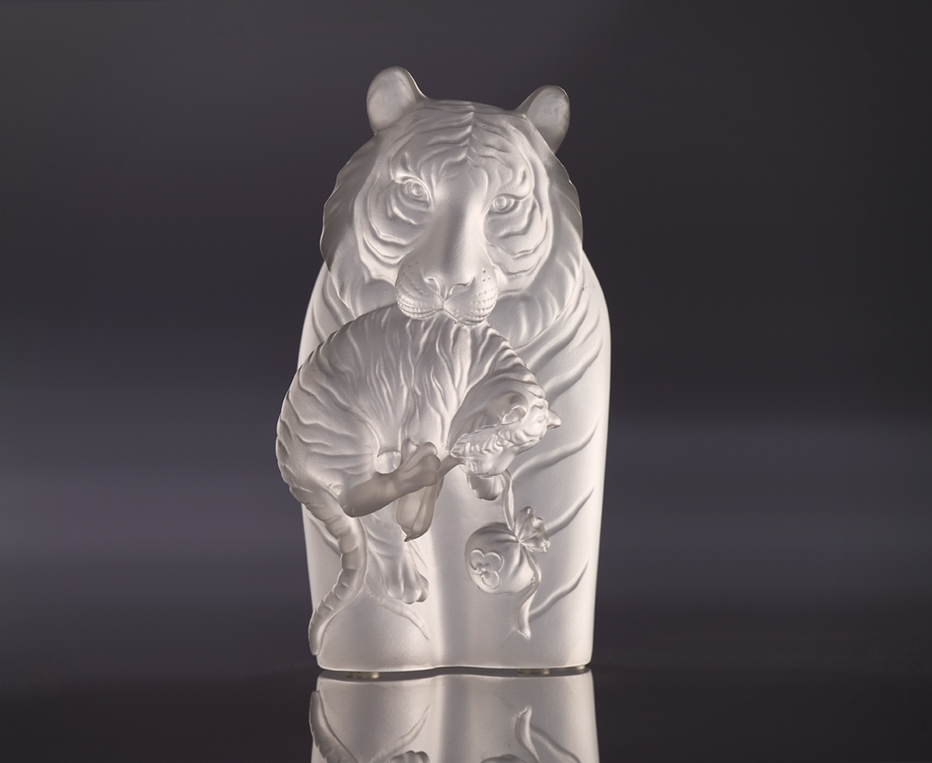
啣深耕的情義
帶厚植的福氣
虎虎興旺 再獲錦囊
齊向康莊大道行
Good Fortune
Profound and intimate relationship Harnesses abundance of good fortune With the audacity of a tiger Wealth and prosperity shall be forthcoming

編號 | 1552809 | No | 1552809
名稱 | 好福氣 | Name | Good Fortune
顏色 | 透(噴砂) | Color
尺寸 | 5 * 6.8 * 12.6 | Size | 5 * 6.8 * 12.6
重量 | 0.6 | Weight | 0.6
限量 | X | Limited Edition | X
售價 | NT$ 5280 | Price | NT$ 5280
 | RMB$ 1160 |  | RMB$ 1160

