歡喜滿載 | 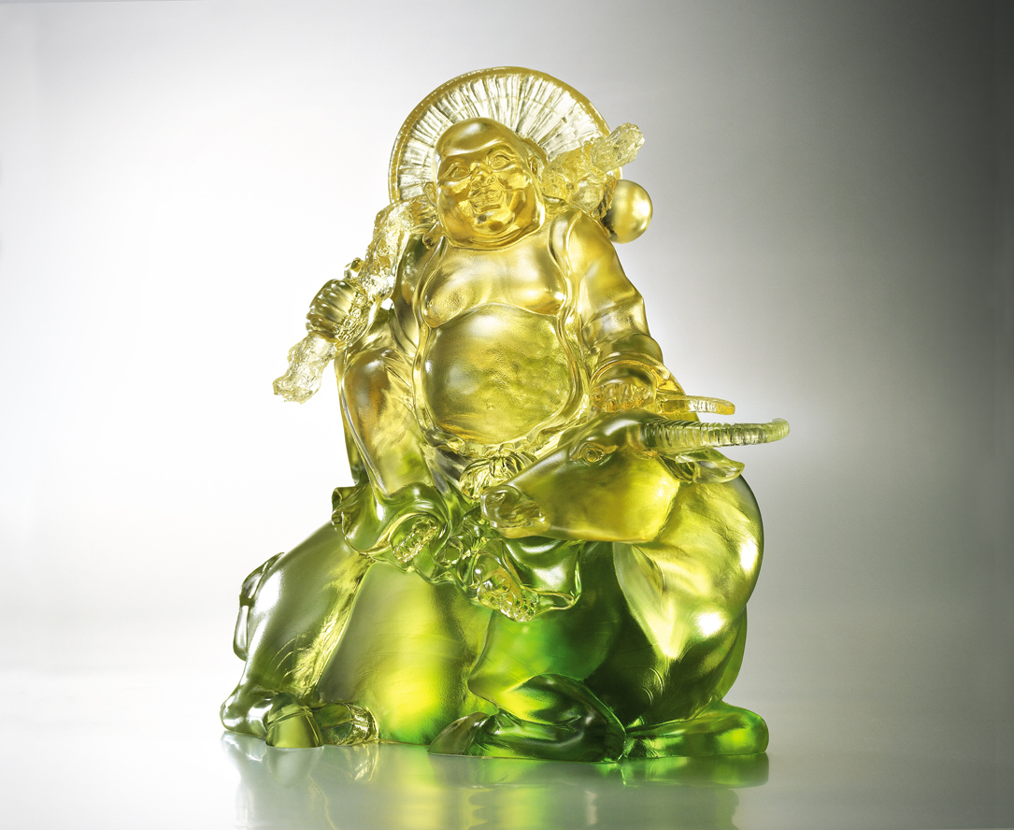
心寬闊 無所求
一身輕安自在
甘願做 歡喜受
一生豐收滿載
Happiness In Full Load
Heart keeps free of restrain, or anything Life is easy, light as spring Willing to work, happy with the load At harvest, it’ll be a pot of gold

編號 | 1552741 | No | 1552741
名稱 | 歡喜滿載 | Name | Happiness In Full Load
顏色 | 金綠透 / 琥透 | Color
尺寸 | 19.2 * 20.5 * 9.2 | Size | 19.2 * 20.5 * 9.2
重量 | 3.2 | Weight | 3.2
限量 | O | Limited Edition | O
售價 | NT$ 18800 | Price | NT$ 18800
 | RMB$ 4600 |  | RMB$ 4600

