浮生荷諧 | 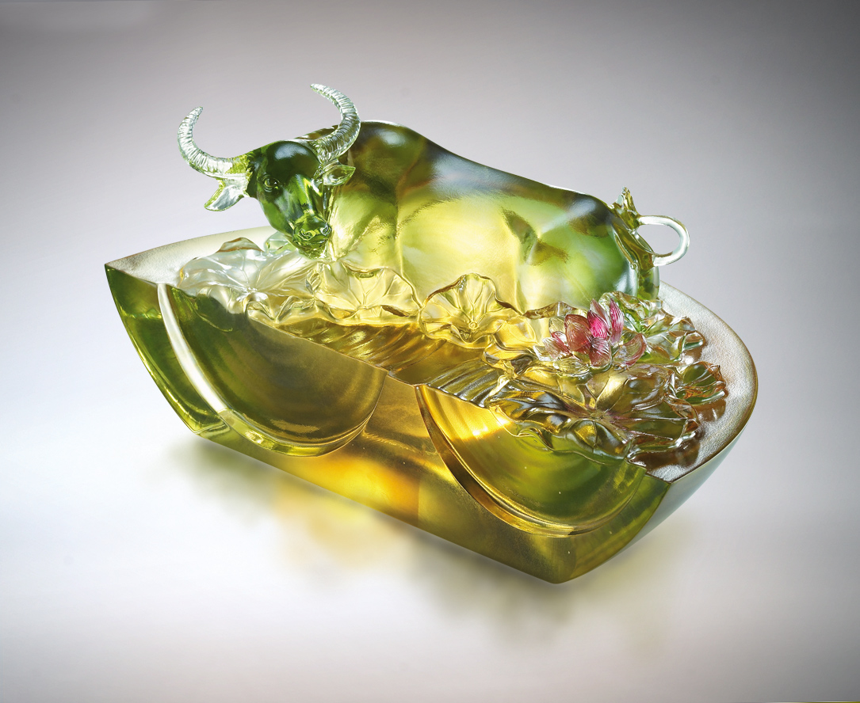
放下所有重量
有浮生荷諧的巧妙
從包容若水得開闊擔當
從自在如風得信心悠遊
Afloat In Harmony
Unload yourself a moment Afloat with lotus in wondrous harmony Like water that engulfs, it carries Like wind that flows, sure and easy

編號 | 1552728 | No | 1552728
名稱 | 浮生荷諧 | Name | Afloat In Harmony
顏色 | 琥綠紅透 | Color
尺寸 | 12 * 23 * 10.9 | Size | 12 * 23 * 10.9
重量 | 2.9 | Weight | 2.9
限量 | O | Limited Edition | O
售價 | NT$ 23800 | Price | NT$ 23800
 | RMB$ 5460 |  | RMB$ 5460

