無懼 | 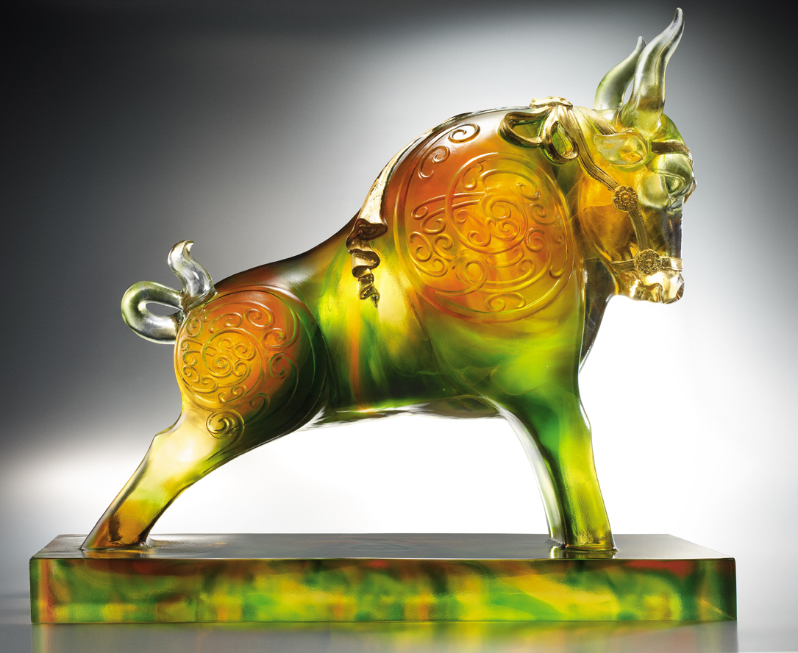
沉思如海 不動如山
蓄勢成竹在胸的實力
堅韌不拔 威武不懼
壯大頂天立地的架式
再衝鋒所向披靡勝境
Fearless
Its thought deep as ocean, and stands like a rock Packed with strength and ready to blast off To none shall it bow, power or brutal force Born to shoulder the sky and keep it tall Fearlessly it shall charges, till victory there is no stall

編號 | 1552723 | No | 1552723
名稱 | 無懼 | Name | Fearless
顏色 | 琥綠透+金箔 | Color
尺寸 | 14.9 * 35.6 * 32.5 | Size | 14.9 * 35.6 * 32.5
重量 | 13.6 | Weight | 13.6
限量 | O | Limited Edition | O
售價 | NT$ 158600 | Price | NT$ 158600
 | RMB$ 37200 |  | RMB$ 37200

